Turning on KVH VSAT Satellite (on Bridge)
The KVH mini VSAT below deck system consists of a Control Unit and Modem that are stacked as one component. On top of the unit are the Ethernet Switch and MTA (Media Terminal Adapter).
1. Power on the Top Control Unit button which will turn green
2. Power on the Lower Modem button which will turn green
3. The KVH system will search for the closest available Satellite connection and the Control Unit LCD screen will display Tracking 125.0W or the nearest available satellite. Be patient as this may take some time.
4. The Control Unit, Antennae, and Modem indicators should all be green
5. The status light at the bottom left of the modem unit should turn green
6. Verify the Ethernet Switch is on
7. Verify the MTA is on.

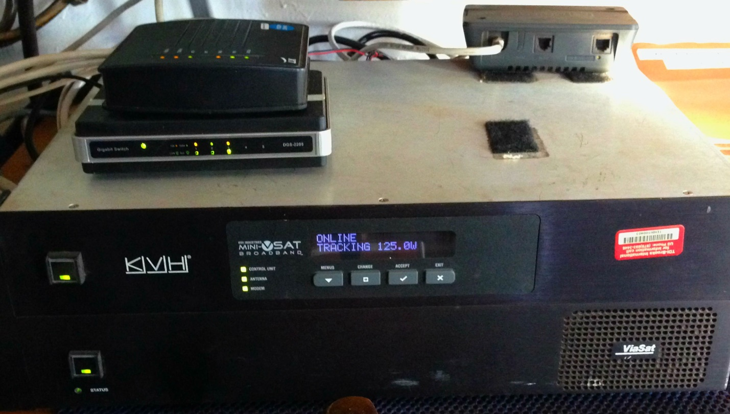
6 ethernet switch

4
7
5
3
2
1
Testing the VSAT (on Bridge)
1. Make a test call using the VSAT phones to the main office (979) 693-3446. The VSAT phone number for BMC is 979-314-4369 (bridge)
2. Send a test e-mail to it@tdi-bi.com
Note 1: VSAT test should only be conducted when the upcoming survey will be out of cell phone coverage. Otherwise, to avoid unnecessary costs, do not test the system for data connectivity. Only test the phone service (step 1) from above.
Note 2: To make sure that data is going through the VSAT connection. Turn off the ZTE Mifi device and wait 60 seconds, before sending a test email.
Note 3: Turn on the ZTE MiFi device once the test of the VSAT's Data connection is complete. In this way, a faster cellular data connection will be available, when in range.

Turning On/Off MiFi device (T-Mobile Hotspot) (on Bridge)
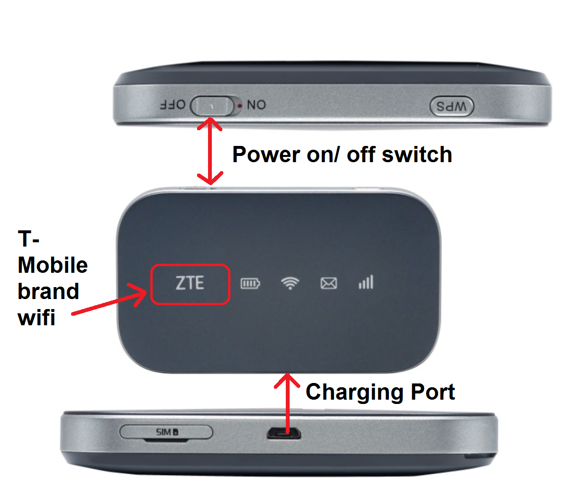
- Make sure the power charger is plugged into outlet and device is charged
- Place unit as close to window or location with signal strength bars are highest

Turning on Shipserver (in Nav room below Bridge)
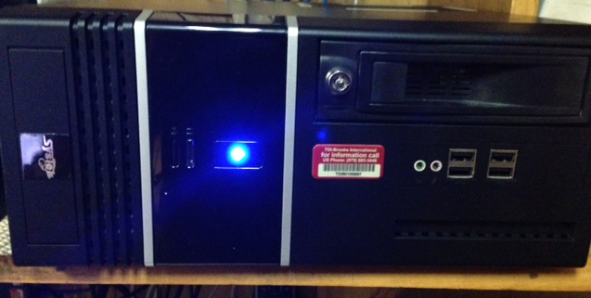

- Push power button and blue light will turn on and server will power up.
- After approximately 10 minutes use another Laptop like the e-mail or NS5 and connect to the N/drive to verify server is up.
- E-mail IT@tdi-bi.com and/or call Office at 979-693-3446 and ask for IT department if server fails to boot or any questions related to the shipserver.

Turning on Sailor 250 (in Nav room below Bridge)
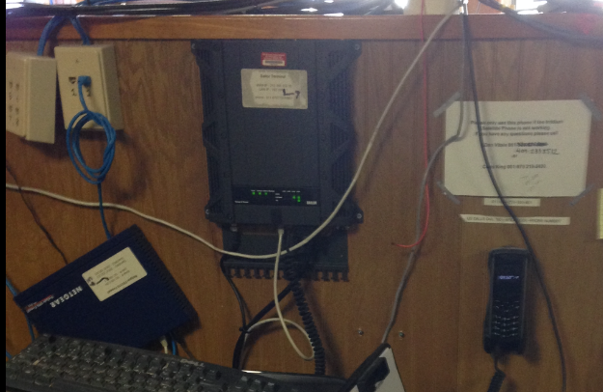
- The power on/off switch for Sailor 250 is on the bottom right of uit
- Once powered on all lights on front panel of Sailor 250 should be green
- Use Sailor phone to the right of the Sailor 250 to make a test call. The BMC phone number should be 870 773 150 801. ( Remember the international dialing code is preceded by 011)
- The Sailor phone is a backup phone and costs can be quite high.

For further assistance please call the IT department at main Office 979-693-3446 or
Chris King 979-219-3430
Will Lewright 979-224-2148
Dan Vitale 979-446-2156

