Name__________________
GHS HazCom Handout
Required to complete the GHS HazCom Quiz & yours to keep.
Write the letter next to the correct GHS Symbols to answer your quiz questions.
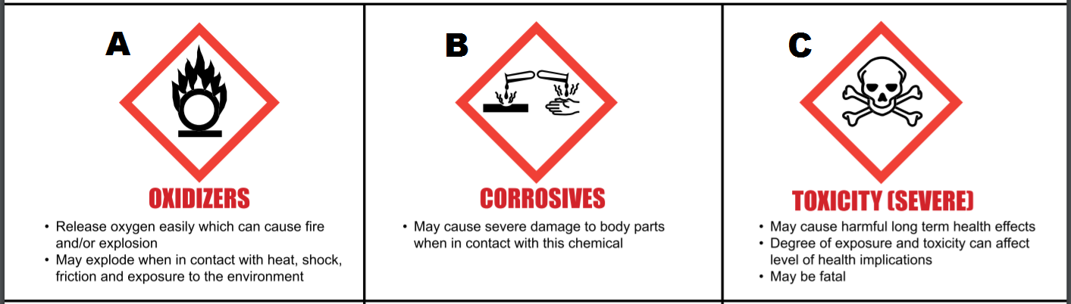
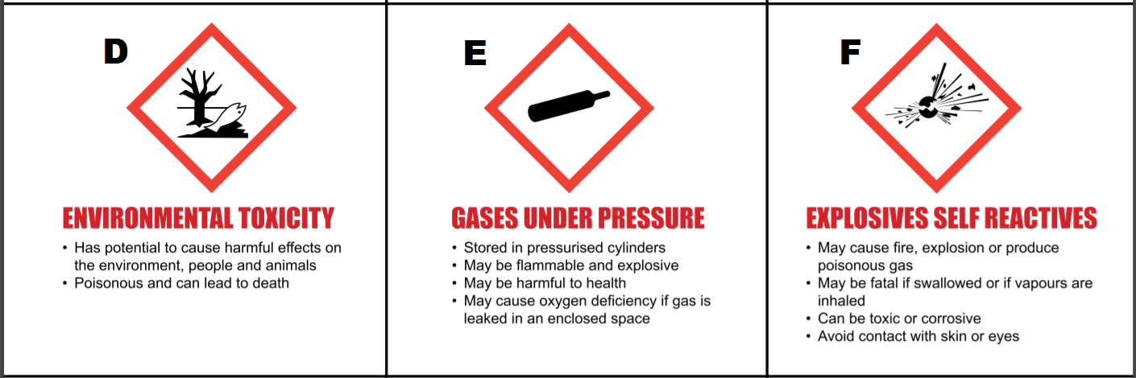
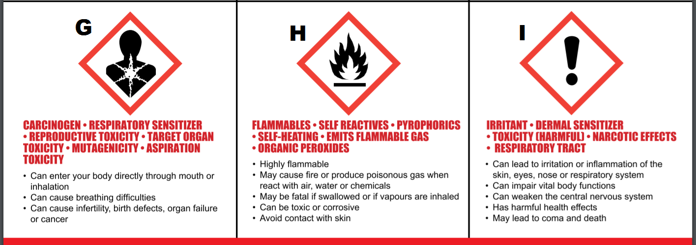

Understanding and using SDS Sheets
Use the following SDS information to answer the final quiz questions.
SDS-Sigmaprime Series Base Grey 1915 (marine paint)
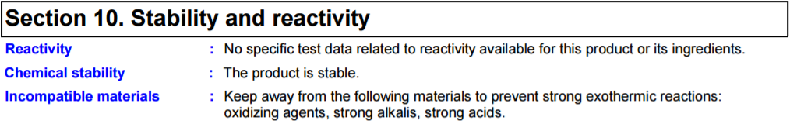
SDS-Clorox Bleach
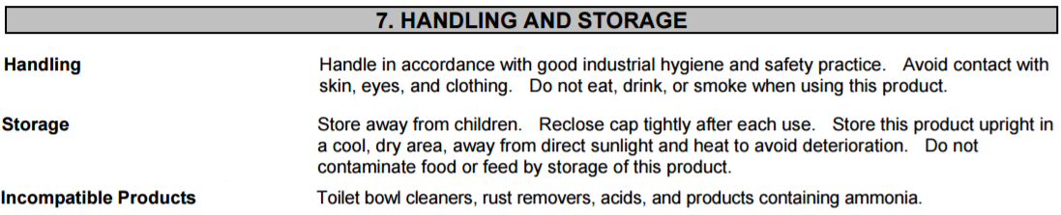
SDS-Gasoline- All grades
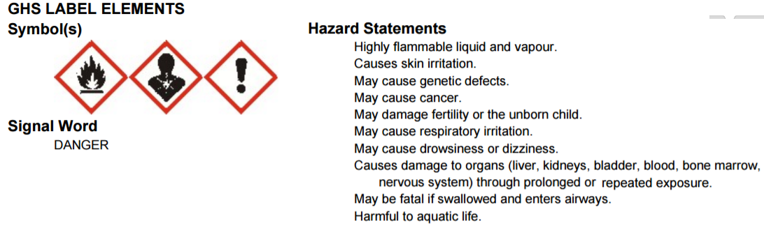
SDS-OSPHO
