http://maritimeaccident.org/library2/the-case-of-the-rusty-assassin/

SAVING LIVES, SAVING SHIPS, SAVING THE ENVIRONMENT

The Case Of The Rusty Assassin

Three men lay dead in the anchor locker.
What they’d needed to live was all around them except in one place:
the air they once breathed.
Their names were Robert Ebertowski, Bob O’Brien and Findlay MacFadyen. Real names, real people. People like you.
The Ship
Their ship was emergency response and rescue vessel, ERRV, Viking Islay which serviced the Ensco 92 jack-up drilling rig in the Amethyst gas field about 25 miles off the East Yorkshire coast. She was classed with Lloyds Register and managed by Vroon Offshore services in Aberdeen.
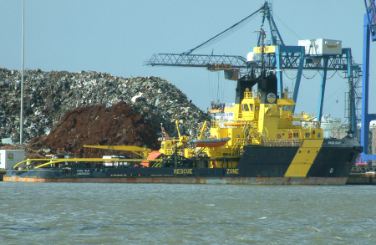
ERRV Viking Islay
The victims
Robert Ebertowski was a 40 year old Polish AB. He’d worked on LPG carriers as an engineer and had worked for Vroon since 2005. He was a day work seaman – he didn’t take a watch but carried out routine duties during the day.
Bob O’Brien was British. Like Robert Ebertowski he was a day work seaman. He was 59, had worked for Vroon for seven years and was the ship’s advanced medical responder. It was a task he was well qualified for, previously he’d been a medic with the British army. On the day of the incident Bob O’Brien was the leading hand, the seaman designated by the ship’s master to be in charge of Robert Ebertowski.
Findlay MacFadyen was a big man. He had been a motorman oiler in the British merchant navy for several years. He’d worked in the ERRV industry for seven years and for Vroon for nearly two years. Now he was the 8/12 seaman, who took the 8 to 12 watch in the morning and evening.
These were experienced, qualified seafarers, used to the ship and their jobs.
Clanking Anchors
On Friday, 21st September Viking Islay docked at Immingham after 28 days on station, for a crew change. On her way into Immingham her starboard anchor had been walked out a short distance to make sure that it was clear to run out in case of emergency.
Her anchors weren’t used much. It was forbidden to anchor near the Ensco 92 rig and she was tied up in port at Immingham. There wasn’t much reason to go into the anchor cable locker except, once in a while, to secure the anchor cable where it entered the spurling pipe that lead to the windlass to stop it making a noise. Most of the time the anchors were in their hawse pipes and the spurling pipes sealed with expanding foam to prevent seawater getting in.
The next day, at 1150, Viking Islay set sail for Ensco 92. The starboard spurling pipe was resealed with foam and at 1625 took up her station to start her 28 day standby.
We can’t know the fine details of everything that happened over the next 24 hours, those who can tell us are no longer alive, but it must have gone something like this:
The weather was fairly benign with 0.5 metre seas and 1.5 metre swells, not uncomfortable but enough to rattle the anchor chain in the spurling pipes. Findlay MacFadyen’s cabin shared a bulkhead with the anchor chain locker and he heard the clank-clank-clank of the chain clearly, especially when trying to sleep.
The mess also shared a bulkhead with the locker, and the noise may have been apparent to them, too.
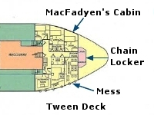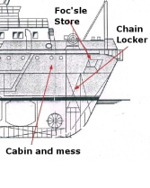
MacFadyen, Ebertowski and O’Brien have breakfast together the next morning and talk about the noise of the anchor chain.
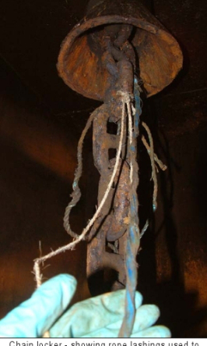
Rattling anchor chains were secured with light rope
Work starts at 8am and MacFadyen takes the watch. He tells the master that Ebertowski and O’Brien want to go into the anchor chain locker to secure the chain and stop it banging. The master agrees but says that the work can be done after a helicopter movement to the rig. It’sViking Islay‘s job to be on standby in case of an emergency.
After the helicopter has left the rig the master goes to his cabin to use the lavatory. MacFadyen is alone on the bridge.
The first victim
At 10.55 Ebertowski and O’Brien take a handheld VHF radio to maintain contact with MacFadyen on the bridge, and go to the foredeck. They open the hatch to the fo’csle store go through the collection of ropes and deck gear to the aft part of the store. There they lift up the loose duckboards to reveal three bolted manholes, one leading to the forepeak water ballast tank and two smaller square ones to the anchor chain locker.
There they undo the 18 bolts securing the manhole cover to the starboard side of the anchor chain locker and remove it.
Ebertowski climbs through the tiny access way into the unlit, unventilated space below with a piece of light rope to secure the anchor chain. He doesn’t make it. He falls, unconscious at the bottom of the ladder.
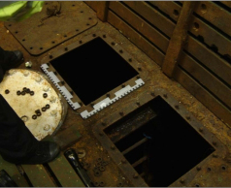
Access to the Anchor Chain Locker

The second victim
O’Brien radios MacFadyen, Ebertowski is in trouble. MacFadyen runs from the wheelhouse, through the accommodation, calling for help. He’s joined by the chief and second mate.
Meanwhile, Bob O’Brien goes down into the anchor locker. He collapses, unconscious, on top of Ebertowski.
Third Victim
MacFadyan and the two mates reach the foc’sle store and look down into the locker. In the darkness below they can see the bodies of Ebertowski and O’Brien.
MacFadyen and the two others go back to the accommodation to get rescue equipment, includi9ng a self-contained breathing apparatus for the rescuers and an emergency escape breathing device for the victims.
By now, the master is back at the wheelhouse and sounds the general alarm at 1107, rousing the rest of the crew. The crew meet at the muster station aft of the accommodation then make their way to the foredeck as the master radios Ensco 92, which prepares to assist Viking Islay.
MacFadyen enters the foc’sle store wearing the breathing apparatus, with him is the ship’s cook carrying the emergency escape breathing apparatus. Another seafarer dons the ship’s second BA set and positions himself beside the foc’sle hatch with the chief mate.
Inside the foc’sle store, MacFadyen tries to enter the anchor locker, but he’s too big to get through the access way wearing the breathing gear. He take off the gear, grabs the emergency escape breathing device from the cook, puts it’s hood over his head and climbs into the anchor locker.
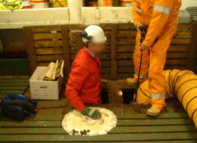
MacFadyen could not get through the hatch wearing a BA
The cook goes to the other side of the foc’sle store to get torches. The chief mate tells another seafarer to put on the discarded BA set and stand by.
When the cook returns to the access way he can see that MacFadyen is in trouble, the emergency escape hood pushed high on his forehead, air still escaping from it, the air bottle laying on the other side of the locker, the hose stretched taut. MacFadyen collapses as the cook looks on, helpless.
Final Toll
One of the seafarers, with a slender build gets through the access way wearing breathing gear. First he checks MacFadyen. The emergency escape breathing device has already run out of air. there is no sign of breathing or pulse. He ties line around MacFadyen, climbs out of the anchor locker and with another seafarer hauls MacFadyen into the foc’sle store. There is still no sign of life.
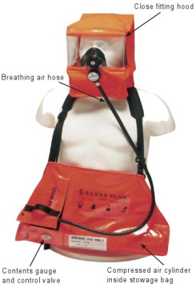
Sabre ELSA EEBD
Then the low air alarm sounds on the first seafarer’s breathing apparatus and both seafarers go up on deck to replace air cylindres. The first seafarer is too exhausted to continue so the third engineer takes over and dons the breathing gear.
The master calls the coastguard for help and more supplies of air. Several nearby ships hear the call and offer help. Meanwhile a specialist, trained, four man-extraction team with a medic is ready onEnsco 92 awaiting transfer to Viking Islay.

It’s now 1125, around half an hour since the collapse of Ebertowski and O’Brien. The two seafarers wearing breathing gear pull MacFadyen out of the foc’sle store to the deck were CPR is tried unsuccessfully.
At 1140, the Viking Islay master maneouvers his vessel close enough to Ensco 92 for the rig’s rescue team to transfer by personnel basket and by 11.51 they’re aboard and take over the rescue efforts. It takes another 40 minutes for both crews working together to get Ebertowski and O’Brien out of the anchor chain locker.
The Rusty Assassin
More than one of the seafarers aboard Viking Islay was astonished that three men, their workmates, could simply collapse and die in an anchor locker. Many of the seafarers on the ship, including the master didn’t think of an anchor locker as a dangerous place even those they had long seafaring experience. And that almost certainly included Robert Ebertowski, Bob O’Brien and Findlay MacFadyen.

Some of the 12 seafarers on Viking Islay certainly were aware of the dangers of anchor chain lockers but not all. Whatever orientation, training and education they’d had wasn’t adequate.
It might have helped if Viking Islay had a list of what dangerous enclosed or confined spaces that crew could refer to. It wasn’t what was in the anchor locker that killed the three men but what wasn’t – Oxygen, yet it was all around them, in the rust on the anchor chain and the bulkheads.
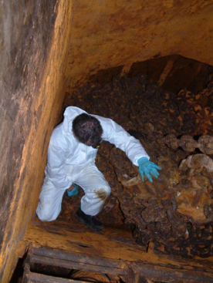
Inside the anchor chain locker
Viking Islay‘s anchor locker was almost airtight. The two small manholes were each bolted down with 18 nuts, with a rubber gasket around the holes to make them water and airtight. The spurling pipes were sealed with expanding foam. Air couldn’t get in or out.
It hadn’t been fully ventilated for fifteen months.
True, a small of air might have got in through the spurling pipes when the anchor chain was broken free of the expanded foam when entering and leaving harbour and when crew members entered to secure the anchor chain, but it was too little to have much effect on the make up of the air in the locker.
We’re all familiar with rust, seafarers spend a lot of time grinding it away, cleaning it off with wire wool and brushes and attacking it with chipping hammers. It’s a ship’s enemy in more ways than one.
The atmosphere inside the locker was damp and salty with seawater. Ideal for iron to react with oxygen and produce rust. The iron sucks oxygen out of the air and, basically, locks it up.
Over weeks and months the anchor chain and bulkheads of the Viking Islay‘s anchor cable locker sucked oxygen out of the air until it might have been as low as 4 per cent in places, about a fifth of what you need to live.
On Viking Islay, and on other ships in the Vroon fleet, men had been into the anchor locker to secure noisy anchor chains. Why didn’t anything happen to them?
In fact it probably did, they just didn’t notice. When securing the anchor chain they didn’t need to go very far into the locker so they were working in the freshest part of the atmosphere while the air below them, where they didn’t go, became increasingly short of oxygen. The air could have had as little as 11 per cent oxygen and they wouldn’t have noticed that their physical and mental performance was being affected. Possibly, Robert Ebertowski initially fell because he was confused due to the lack of oxygen.
Effects of Oxygen Depletion
Per cent Oxygen(By volume) | Effect
18-21 | No discernible symptoms can be detected by the individual.
11-18 | Reduction of physical and intellectual performance without the sufferer being aware.
8-11 | Possibility of fainting within a few minutes without prior warning. Risk of death below 11 vol%.
6-8 | Fainting occurs after a short time. Resuscitation possible if carried out immediately.
0-6 | Fainting almost immediate. Brain damage may occur,even if rescued.
Also, it’s likely that no-one had been into the anchor locker since before the summer so it had remained closed for a long period with the rust sucking more and more oxygen from the air. By the time Robert Ebertowski entered the locker on 23rd September the level of oxygen could have been low enough to cause almost immediate unconsciousness. Below 6 per cent oxygen, fainting is almost immediate and even if you’re rescued there’s a good chance of permanent brain damage
Why didn’t they test the air before going in? They couldn’t. Vroon Offshore’s policy was that no-one should enter an enclosed space unless the ship is in port and with specialist personnel present. It must have seemed like a good idea to the management office ashore but it’s simply not realistic under normal operating conditions at sea. It hadn’t been thought through.
It didn’t provide guidance on what should be considered a dangerous space and under what conditions.
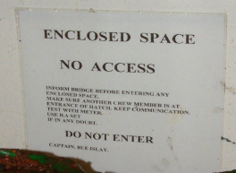
The warning signs had little impact
When companies make impractical rules those rules soon get ignored or re-interpreted. On theViking Islay and other ships in the fleet, seafarers were regularly going to the anchor locker to tie off anchor chains. It wasn’t a matter of urgency yet it put them at risk. They didn’t take much notice of the sign attached to the aft bulkhead of the foc’sle store, above the access hatches to the anchor chain locker that said, in big, readable letters “Enclosed Space – No Access – Do Not Enter” because they didn’t know the risk.

Because of that no-go policy, Viking Islay was not provided with the appropriate atmosphere testing equipment. The men couldn’t have tested the atmosphere even if they wanted to. There had once been a personal oxygen alarm unit on board, a Crowcom Eikon, it couldn’t be used for testing oxygen levels in an enclosed space. By the time of the incident it had been replaced with a disposable personal hydrogen sulphide gas monitor. Not quite the right tool for the job.
In fact, there weren’t any portable fans or lights aboard Viking Islay, either. Nobody was supposed to go into spaces that required extra lighting or ventilation.
The Vroom policy was, to say the least, shortsighted.
Vroom did, of course, have a safety management system. It was followed in June 2006 when contractors carried out work in that same anchor locker while in port, but it was not followed when men went into the anchor locker to secure the chains.
Men on Viking Islay did undergo drills for rescuing people from confined spaces using the ship’s laundry but they hadn’t done drills to practice getting through the sort of small access hatches that lead into the anchor chain locker.
If they’d done so, they’d had foreseen the problem of getting a big man like Findlay MacFayen through such a small hatch with BA gear on his back. If they’d have known that, then maybe a smaller man might have been chosen or they’d had used the same technique as the Ensco 92extraction team: put the air tank through first while keeping the mask in place.
With that knowledge, Finlay MacFadyen wouldn’t have had to resort to the emergency escape breathing device. EEBDs are one-way tickets, you don’t use them for going into a situation, you use them for getting out of one. Under the best conditions possible he had 10 to 15 minutes of air. But these weren’t the best of conditions.
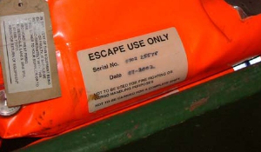Unlike self contained breathing apparatus, EEBDs deliver a fixed amount of air. The chances are that MacFadyen was trying to breath more air that the unit could supply, the hood closed in over his face and he felt as if he was suffocating. That’s when he pushed up the hood, tried to breathe the oxygen deficient air and collapsed.
MacFadyen hadn’t been exposed to realistic training in the use of EEBDs under stress. Had he been, his decisions might have been quite different.
Vroom’s sms system required several steps before entry into an enclosed space: A risk assessment, the preparation of a toolbox talk risk identification card and the issue of a permit to work.
At the time, Vroom’s SMS risk assessment for this kind of entry didn’t clarify its no-go policy and individual ships were authorised to make their own risk assessments. There were several errors on Viking Islay‘s risk assessment, including a disparity between the risk assessment and what was available onboard.
TRIC, or Toolbox-talk Risk Identification Card, is a safety system used in the offshore industry. Any non-routine task requires a TRIC, which identifies hazards not covered in the risk assessment and control measures needed and records them on the card which is signed by the master before work begins.
On Viking Islay it was common for TRIC’s to be signed after the job was done, which made them a pointless exercise.
Because the master didn’t think of the anchor locker as an dangerous space, which may be why he approved the job without talking to the mate who normally supervised deck operations. All the same, going into the chain locker wasn’t a normal part of the seafarer’s day so he should have had the seafarers follow the TRIC procedures at the very least before starting work.
Another part of the safety system is the Permit To Work, or PTW, to be completed and issued before work begins. That wasn’t done either.
These paper systems, like the enclosed space entry permit used on other ships make sure that you know what the risks are, that you have what you need to stay out of trouble, and what’s needed to get you out of trouble if something goes wrong.
There is one rule that would have kept O’Brien and MacFadyen alive: Don’t attempt to rescue someone from a confined space without backup and the right equipment and training. It’s instinctive to go straight in after a shipmate in trouble or unconscious without thinking of your own safety when you don’t actually know what’s causing the problem.
One of the reasons why enclosed space or confined space casualties are so high is that, too often, would-be rescuers die, too. Like a supermarket two-for-one offer, death gets a discount.
It takes discipline not to go after a shipmate in trouble until you’ve ensured your own life isn’t at risk. If you don’t have that discipline you reduce the chances of saving your friend, you increase the dangers to yourself, and you put the lives of your other shipmates on the line.
As a seafarer you have a right to working conditions that are as safe they can reasonably be, but you also have a responsibility, to yourself and your shipmates to work as safely as you can, to keep your wits about you and an eye out for dangerous situations.
How do you avoid being a victim of the Rusty Assassin?
First, think about whether you really have to go into the space at all, is the job that urgent or is there another way to solve the problem.
If there’s rust in a space, it could be an anchor chain locker or a ballast tank or a cargo hold, assume that its dangerous, even if it’s not mentioned in the SMS or on a list of dangerous spaces. Your brain is there to be used. Use it or lose it.
Test and ventilate the space until the oxygen is around 21 per cent. If you can’t test or ventilate – and the men on the Viking Islay couldn’t – then don’t go in until or unless it can be ventilated.
Keep a safety watch.
Always have rescue equipment immediately available beside the point of access. Don’t just plonk it there, think about how you’re going to use it. Can you get through the accessway wearing a breathing apparatus? Are you sure. And if you’re the one going into the space make sure the person of safety watch knows how to use the equipment.
Don’t be tempted to use an EEBD for rescue, its for escape only. It’s a one way ticket.
Follow the safety procedures in the SMS, make sure all the necessary documents are completed and signed before you enter the space. They’re as important as the brakes on your car.
Every job aboard ship should have a Job Safety Analysis, JSA, which identifies safety issues in carrying out the job. There wasn’t one for securing the anchor chain on the Viking Islay, probably because it wasn’t a formal ‘job’. If there isn’t a job safety analysis for the task your carrying out, you’d better find out why.
Before carrying the job, a toolbox talk should identify who does what, the tools needed, the risks involved and what to do if something does go wrong. It’s a good way of reminding yourself and others of safety issues and precautions. There wasn’t a toolbox talk on the Viking Islay and the results speak for themselves.
It doesn’t matter how often you’ve done that job, have that toolbox talk. The more often you do a job, the more familiar you get with it, the more likely you’ll forget safety precautions.
Even if others on your ship, including officers, have a casual attitude towards safety remember it’s your life, your choice.
And don’t take shortcuts. A short cut too often leads to a dead end.
Posted by bobcouttie at 15:58

