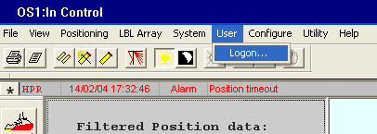

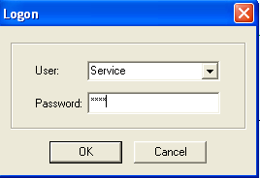

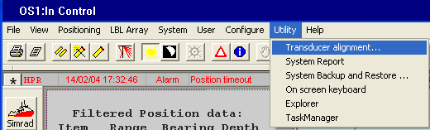

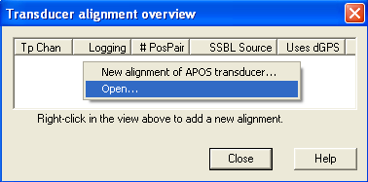

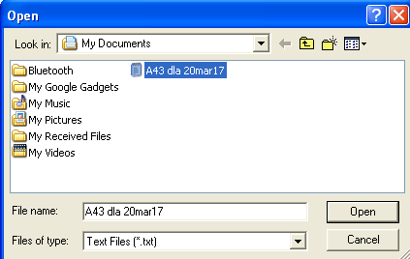

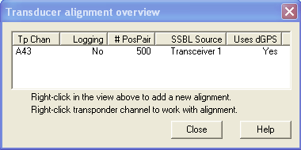

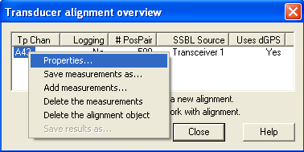

Un-check Auto-Exclude and verify the other settings are per figure below > select “Graphically” under view measurements.

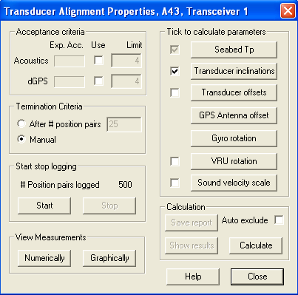

There should be 3 boxes > Using the top box “MeasTpDepth” Right-click and box in the top points of the top half of the graph > select “Exclude inside”

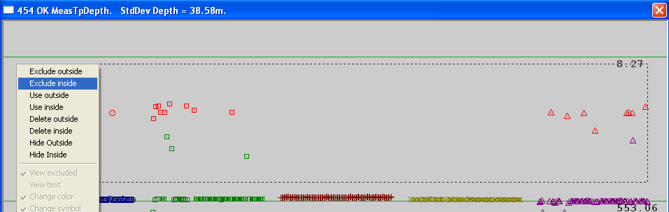

Repeat his same process for the lower half of the graph.

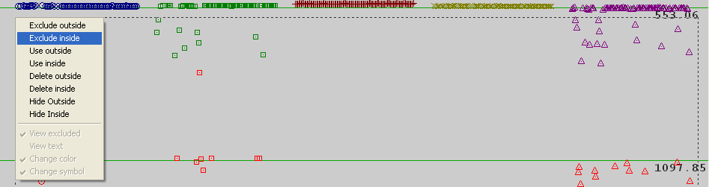

Close all three boxes

Select Calculate
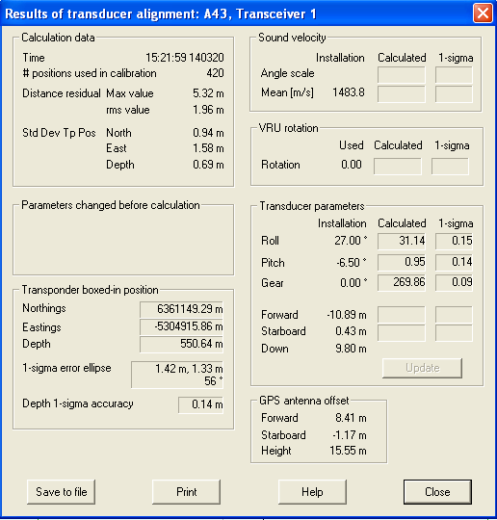

Select “Graphically” under View Measurements

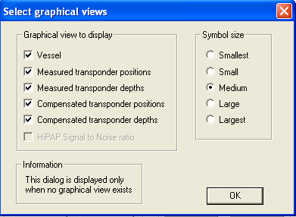

Right click and box in the top half of the graph “all points” and select “Exclude inside”

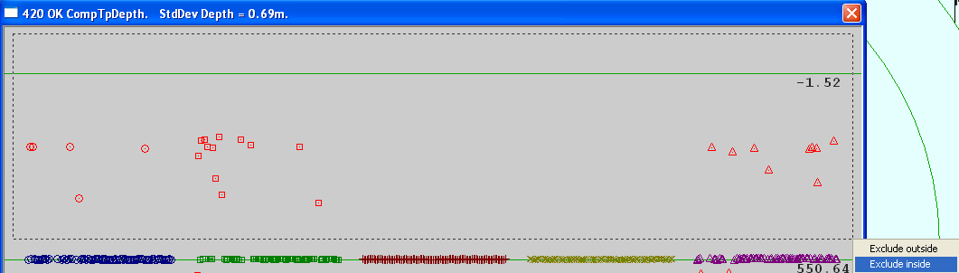

Right click and box in the bottom half of the graph “all points” and select “Exclude inside”

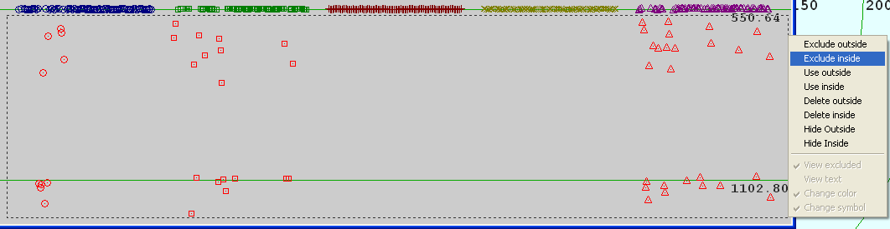

Right-click on top blue bar and save to file > then close > and complete this on the remaining 4 open screens. Note: There should be 5 jpeg saved files for each box.

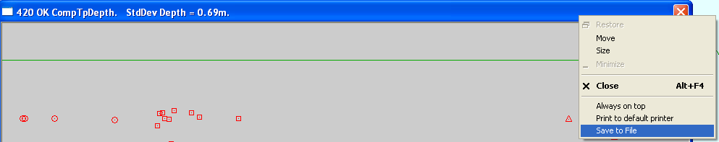

Select Calibrate again?



