TDI-Brooks International, Inc.
1902 Pinon Dr.
College Station, Texas 77845
Phone: (979) 693-3446
Fax: (979) 693-6389
Email: berniebernard@tdi-bi.com

Standard Operating Procedure

PROCEDURAL STEPS FOR NAVIGATION

By Diana Solís-Solís
Revision No. 2
By Adam Ariganello March 2018

By our signatures below, we hereby approve this Standard Operating Procedure:

_____________________________________________ ________________
Bernie B. Bernard, Vice President Date

_____________________________________________ ________________
Date

_____________________________________________ ________________
Kathleen Nease, Quality Management Representative Date

Page 1 of 91

TABLE OF CONTENTS

TITLE PAGE 1

TABLE OF CONTENTS 2

LIST OF FIGURES 4

LIST OF ANNEXES 7

SECTION 1: GENERAL INTRODUCTION TO THE NAVIGATION/POSITIONING SYSTEM 8
1.0 Introduction 8
2.0 Software Programs Utilized in the Vessel´s Navigation Station 9
3.0 The APOS Program Screen 10
4.0 The WinFrog Program Screen 11
4.1 Introduction 11
4.2 The WinFrog Position Map Screens (Graphics) 11
4.2.1 Introduction. 11
4.2.2 Some Troubleshootiing 12
4.3 The WinFrog Program Vehicles 13
4.3.1 Introduction. 13
4.3.2 Displayed Information 13
4.3.3 Editing Displayed Information 15
4.3.4 Some Troubleshootiing 17
5.0 The Discover Sub-Bottom Program Screen 17
5.1 Introduction 17
5.2 The Oscilloscope Wave Form (Envelope) Display 18

SECTION 2: GENERAL NAVIGATIONAL PROCEDURES 19
1.0 Services Rendered by the Navigation Operator 19
1.1 General Responsabilities 19
1.2
1.3
2.0 First General Steps of Navigation Operation 24
2.1 Introduction 24
2.2 Setting Up WinFrog Working Files (Creation of Waypoints) 25
2.2.1 Introduction. 25
2.2.2 Procedure to Create a Waypoint 25
2.3 Editing WinFrog Working Files (Modification of Waypoints) 27
2.4 Setting up WinFrog Waypoint Tracking (Activation of Waypoints) 29
2.5 Tracking the Beacon After Core Rig Deployment 30
2.5.1 In the Apos Program 30
2.5.2 In the WinFrog Program 31
2.5.3 Beacon Signal Troubleshooting 32

SECTION 3: CPT STINGER CORING 34
1.0 Introduction 34
2.0 Procedures to Follow Before Reaching the Active Waypoint 34
2.1 Setting up WinFrog Working Files (Creation of Waypoints) 34
2.2 Setting up WinFrog Waypoint Tracking (Activation of Waypoints) 34
2.2.1 For Sites Cored for the First Time 34
2.2.2 For Previously Tested Sites 34
2.3 Setting up the Top-Black Banner 37
2.4 Setting up the Beacon’s Profile-1 Graphics Screen 38
2.4.1 Introduction 38
2.4.2 Creating a New Survey Line for Beacon Tracking 38
2.4.3 Scale Adjustments 39
2.5 Configuring Offsets 40
3.0 Procedures to Follow On Station 40
3.1 Tracking the Beacon After Core Rig Deployment 41
3.2 Preparation for Strike 41
3.2.1 Manual Event 100 m Before the Strike Distance 41
3.2.2 Logging Data 20 m Before the Strike Distance 42
3.3 Strike of Barrel 43
3.3.1 Initial Steps 43
3.3.2 The Possibility of Obtaining Primary Data 43
3.4 Barrel Retrieval 45
3.4.1 Initial Steps 45
3.4.2 Screen Capture 20 m After Strike Distance is Passed 45
3.5 Position Averaging Report (PAR) 4Error: Reference source not found
3.6 Before Barrel is Back on Deck 49
3.7 After full Barrel Retrieval 50
3.7.1 Verification of Acquisition of Good Data 50
3.7.2 Barrel on Deck 50

SECTION 4: PRELIMINARY GEOCHEMICAL PISTON CORING PROCEDURES 5Error: Reference source not found
1.0 Introduction 51
2.0 Procedures to Follow Before Reaching the Active Waypoint 51
2.1 Setting up WinFrog Working Files (Creation of Waypoints) 51
2.2 Setting up WinFrog Waypoint Tracking (Activation of Waypoints) 51
2.3 Creating a New Survey (Chirp) Line for Sub-Bottom Image Recording 51
2.4 WinFrog Data Events Setup (For Automatic Fix Marks in Chirp Software) 54

SECTION 5: PRELIMINARY HEAT FLOW SURVEY PROCEDURES 56
1.0 Introduction 56
2.0 Procedures to Follow Before Reaching the Active Waypoint 56
2.1 Setting up WinFrog Working Files (Creation of Waypoints) 56
2.2 Setting up WinFrog Waypoint Tracking (Activation of Waypoints) 56
2.3 Creating a New Survey (Chirp) Line for Sub-Bottom Image Recording 56
2.4 WinFrog Data Events Setup (For Automatic Fix Marks in Chirp Software) 59

SECTION 6: GENERAL HEAT FLOW AND GEOCHEMICAL PISTON CORING PROCEDURES 6Error: Reference source not found
1.0 Procedures to Follow Shortly Before Reaching a Chirp Survey Line Error: Reference source not found1
1.1 In the WinFrog Program 61
1.2 In the Edge Tech Discover Program 63
2.0 Procedures to Follow to Run the Survey Line Error: Reference source not found6
2.1 Running a Chirp Line and Recording the Sub-Bottom Image 66
2.2 Re-Running a Chirp Line 68
2.3 Processing the Sub-Bottom Chirp Image from the Discover Program 72
3.0 Preparing for Coring Before Reaching the Station 73
4.0 Procedures to Follow On Station 75
4.1 Tracking the Beacon After Core Rig Deployment 75
4.2 Strike of Barrel 75
4.3 Before Barrel is Back on Deck 77
4.4 After full Barrel Retrieval 78
4.4.1 Verification of Successful Heat Flow Data Data Recovery 78
4.4.2 Filling out the Corelog Database 79

REFERENCES 91

List of Figures

Figure 1. Communication scheme between APOS, the transceiver, transducer and

Transponder using electric and acoustic signals . 8

Figure 2. Integrated vessel and core rig navigation system. 9
Figure 3. APOS’s working screen 10
Figure 4. APOS’s main menu bar, speed toolbar and column of transponder symbols 10
Figure 5. Status bar at the bottom of APOS’s window screen 10

Figure 6. The main menu bar and speed toolbar on WinFrog’s Screen-1 11

Figure 7. WinFrog’s Screen-1 displaying the Graphics-1 window, the main menu bar

and toolbar buttons 11
Figure 8. WinFrog’s Screen-2 displaying the top-black banner, Graphics-2, Profile-1,
Vehicle-1 and 2 windows. 12

Figure 9. Creating a new Graphics screen in WinFrog 12
Figure 10. Configuring the grids on a new graphics screen in WinFrog 13

Figure 11. WinFrog’s Vehicle-1 and 2 windows 13
Figure 12. WinFrog’s Vehicle-1 window displaying several information points 14

Figure 13. A WinFrog’s graphics screen displaying a vessel crabbing 14
Figure 14. The vessel’s pitch and roll in open water. 15

Figure 15. WinFrog’s “Configure Vehicle Text” window 16
Figure 16. WinFrog’s Vehicle-2 window displaying different formats on its rows 16

Figure 17. WinFrog’s “Configure Units” window 16
Figure 18. Opening a pre-existing vehicle window in WinFrog 17
Figure 19. Discover Sub-Bottom's working screen 18
Figure 20. Section of the Discover Sub-Bottom's Wave Form Display showing the
bottom track threshold and range, bottom tracker and bottom reflections 18

Figure 21. A CoreLog Database properties window 20

Figure 22. The “CoreLog Data” window 21
Figure 23. Adding the chirp bitmap on the CoreLog Database 22

Figure 24. The “Insert Object” window for adding the chirp bitmap in the CoreLog

Database. 22
Figure 25. The Chirp tab in the CoreLog Database with added notes and chirp bitmap 23

Figure 26. Setting the “Fix” on the “Position” box in the CoreLog Database 24

Figure 27. Instructions to add a new waypoint in WinFrog 25
Figure 28. The “Working Waypoints” file in WinFrog, named after the job number 26

Figure 29. WinFrog’s “Waypoint” window 26
Figure 30. Filling out WinFrog’s “Waypoint” window to add a new site 2Error: Reference source not found

Figure 31. Editing a waypoint from WinFrog’s “Working Waypoints” File 2Error: Reference source not found
Figure 32. Editing a waypoint in WinFrog’s “Waypoint” window. 28

Figure 33. Site to save a modified WinFrog waypoint file 28
Figure 34. Setting up waypoint tracking on a vehicle window in WinFrog. 29

Figure 35. A “Setup Waypoint Tracking” window for a vehicle in WinFrog 29
Figure 36. Section of APOS’s screen displaying the beacon symbols and “Filtered
Position data” box 30

Figure 37. Section of APOS’s screen displaying the vessel’s pitch and roll 31
Figure 38. Appropriate positioning of WinFrog’s windows to clearly display
the vessel, beacon and Bulls-eye 32
Figure 39. WinFrog’s Profile-1 and Vehicle-2 screens displaying accurate signal
from the beacon 32
Figure 40. Excel file showing the CPT settings 35

Figure 41. Adding a site's coring date on the Excel CPT Settings file 35
Figure 42. In WinFrog, adding another coring location in a previously tested site 36

Figure 43. WinFrog Bulls-eye with several deployment sites. 36
Figure 44. Notepads for CPT coring with core information for winchman and bridge:
A1&A2) Preliminary ones ready before strike for long and short barrels;
B1&B2) Filled out ones after strike for long and short barrels 37
Figure 45. Proper positioning of Notepad with core information for winchman
and bridge on WinFrog’s Screen 2 38
Figure 46. Creating a survey line for beacon tracking in WinFrog 39
Figure 47. WinFrog’s “Configure Profile-1” window 39
Figure 48. WinFrog’s “Configure Offsets” window set on the “A-frame” 40

Figure 49. Vehicle settings configured on the vessel’s A-frame 40
Figure 50. WinFrog’s F10 “Manual Event” window. 41
Figure 51. Format for WinFrog’s “Position Averaging” window when total depth is known 42
Figure 52. WinFrog’s “Position Averaging” window actively logging data 42
Figure 53. WinFrog’s I/O Devices-1 window with all green icons 43
Figure 54. WinFrog’s “Configure Graphics” screen set to “Plot Log files” 44
Figure 55. APOS screen displaying the beacon’s trajectory 45
Figure 56. WinFrog’s “Position Average for Corer” window showing measurements that
must be inactivated according to the time they were logged. 46
Figure 57. Inactivating erroneous measurements on WinFrog’s “Position Average for
Corer” window. 4Error: Reference source not found
Figure 58. WinFrog’s “Select Position File” window 4Error: Reference source not found
Figure 59. Creating the “rft.” file for the Position Averaging Report (PAR) in WinFrog 48
Figure 60. A Position Averaging Report (PAR) on WinFrog 49
Figure 61. The “Working Waypoints” and “Waypoint” windows in WinFrog. 51
Figure 62. WinFrog’s “Surline” and “Preplot Grid” windows with proper setup
for geochemical coring 52
Figure 63. Bulls-eye with a green “survey line” and white “line tracking” configured
in WinFrog 52
Figure 64. WinFrog’s “Setup Line Tracking” window with setup for geochemical coring 53
Figure 65. WinFrog’s “Raw Logging Warning” window 53
Figure 66. Inactive “Start” (FX) and “Stop” buttons for the chirp in WinFrog 54
Figure 67. WinFrog’s “Event Configuration” window with proper setup for geochemical
coring chirping 54
Figure 68. WinFrog’s “Distance Fixing” window 55
Figure 69. WinFrog warning windows 55
Figure 70. The “Working Waypoints” and “Waypoint” windows in WinFrog. 56
Figure 71. WinFrog’s “Surline” and “Preplot Grid” windows with proper setup
for heat flow surveying 57
Figure 72. Bulls-eye with a green “survey line” and white “line tracking” configured
in WinFrog 57
Figure 73. WinFrog’s “Setup Line Tracking” window with setup for heat flow surveys 58
Figure 74. WinFrog’s “Raw Logging Warning” window 58
Figure 75. Inactive “Start” (FX) and “Stop” buttons for the chirp in WinFrog 59
Figure 76. WinFrog’s “Event Configuration” window with proper setup for heat flow
chirping 59
Figure 77. WinFrog’s “Distance Fixing” window 60
Figure 78. WinFrog warning windows 60
Figure 79. WinFrog’s “Configure Offsets” window set on the “Chirp” 61
Figure 80. Vehicle settings changed from the vessel’s “A-frame” to the “Chirp” 62
Figure 81. Configuring WinFrog’s vehicles on the vessel 62
Figure 82. Centering the Graphics-2 screen on the vehicle in WinFrog 63
Figure 83. Initiating the chirp by pressing the “Ping SB+-“ button on the speed toolbar
in Discover 63
Figure 84. Adjusting the depth scale for the sub-bottom image on Discover 64
Figure 85. Aligning the red, green and blue lines with the sub-bottom image on
Discover 64
Figure 86. Opening the “Control Panel Options” window via the speed toolbar in
Discover 65
Figure 87. Discover’s “Control Panel Options” window with the “Display” tab open 65
Figure 88. Adjusting the tracking window width in Discover 65
Figure 89. The “Record” tab on the “Options” window in Discover. 66
Figure 90. Active “Start” (FX) button for the chirp in WinFrog’s speed toolbar. 67
Figure 91. “New Mark” speed toolbar button on Discover 67
Figure 92. “Record” speed toolbar button on Discover 67
Figure 93. Active “Stop” (FX) button for the chirp in WinFrog’s speed toolbar 67
Figure 94. A WinFrog’s graphics screen displaying a vessel crabbing while heading
to the survey line 68
Figure 95. WinFrog’s “Survey Line Tracking” window displaying the “Reverse”
option selected 68
Figure 96. Unclear image recorded of EGM081’s core sub-bottom because of an
inappropriate survey line heading (HDG295) 69
Figure 97. Clear image recorded of EGM081’s core sub-bottom because of an
appropriate survey line heading (HDG050) 69
Figure 98. Displaying the sub-bottom’s depth on Discover with the cursor 70
Figure 99. Notepads for geochemical coring with core information for winchman and
bridge: A) Preliminary one ready before strike; 2) Filled out one after strike Error: Reference source not found0
Figure 100. Proper positioning of Notepad with core information for winchman and
bridge on WinFrog’s Screen 2 71
Figure 101. Preliminary notepads with core information for regular and Pogo heat
flow surveys (before strike) 71
Figure 102. Filled out notepads with core information for regular and Pogo heat
flow surveys (after strike) Error: Reference source not found1
Figure 103. Discover’s “Control Panel Options” window with the “Playback” tab open Error: Reference source not found2
Figure 104. Adjusting the horizontal zoom on the recorded sub-bottom image Error: Reference source not found2
Figure 105. Image of the sub-bottom with proper format for the CoreLog Error: Reference source not found3
Figure 106. WinFrog’s “Configure Graphics” window with the “Center on Waypoint”
selected Error: Reference source not found3
Figure 107. WinFrog’s “Configure Offsets” window set on the “A-frame” Error: Reference source not found4
Figure 108. Vehicle settings changed from the vessel’s Chirp to the A-frame Error: Reference source not found4
Figure 109. Configuring WinFrog’s Vehicle-3 on the USBL beacon Error: Reference source not found5
Figure 110. WinFrog´s “Manual Event” window with core strike location information Error: Reference source not found6
Figure 111. Turning the “Event Start” for the chirping off in WinFrog’s “Event
Configuration” window. Error: Reference source not found7
Figure 112. Inacceptable data results obtained from a heat flow survey Error: Reference source not found8
Figure 113. Good data results obtained from a heat flow survey Error: Reference source not found8

LIST OF ANNEXES

Annex 1. DPR 11/12/2010 R/V Brooks McCall. . 80

Annex 2. DPR 11/14/2010 R/V Brooks McCall.. 83

Annex 3. DPR 11/15/2010 R/V Brooks McCall. 85

Annex 4. WinFrog's Manual Event printout and lab report for core (beacon with normal

signal) 87

Annex 5. WinFrog’s Manual Event printout and lab report for core (beacon with erratic

signal) 89

SECTION 1:
GENERAL INTRODUCTION TO THE NAVIGATION/POSITIONING SYSTEM

- INTRODUCTION

TDI-Brooks conducts multi-disciplinary offshore projects by using Differential Global Positioning System (DGPS) satellite signals for navigation/positioning purposes and an Ultra-Short Baseline (USBL) acoustic sonar system for core rig positioning in the water. The DGPS is run by the WinFrog navigation program and the sonar positioning system by the APOS program.

The operation station (APOS) controls a transceiver, USBL transducer and transponder, which all are both transmitters and receivers of signals:

- The transceiver: it measures ranges and USBL directions and handles the telemetry (transmission and measurements of data from remote sites). It works with only with electric signals.

- The transducer: it’s located in the vessel and measures ranges and directions. It converts the transceiver’s electrical signals into hydroacoustic pulses and converts received hydroacoustic pulses coming from the transponder into electrical signals that can be read by the transceiver.

- The transponder (beacon): it’s located on the coring device, which makes possible the positioning of the core rigs. It’s commanded by telemetry to execute functions. It works only with hydroacoustic signals.

The position of the beacon is determined by the transducer, which dynamically controls a narrow reception beam towards its location. The transponder is questioned by pulses of two different frequencies and will respond with a pulse of a third one. The determination of the distance range is calculated by considering the time delay between the interrogation and reception. The navigation and USBL computers obtain real-time position and time data in digital format via the DGPS system (Fig. 1 and 2).

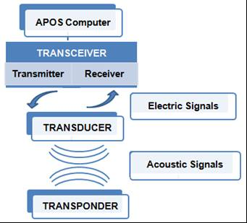
Figure 1. Communication scheme between APOS, the transceiver, transducer and transponder using electric and acoustic signals.
Figure 2 displays a diagram of the integration of the vessel and core rig navigation system. The USBL transducer can be installed both on the moon tube or a side-mounted pole. Also, the pitch and roll sensors of the vessel can be installed on the transducer pole or near the navigation computers.

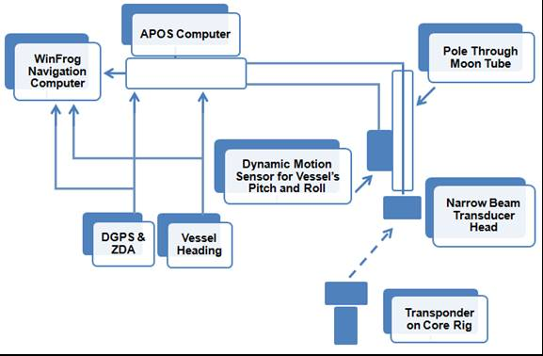

Figure 2. Integrated vessel and core rig navigation system

- SOFTWARE PROGRAMS UTILIZED IN THE VESSEL´S NAVIGATION STATION

- WinFrog 3.7 Integrated Navigation System by Fugro Pelagos, Inc.: for navigation/positioning purposes.

- APOS (Acoustic Positioning Operator Station) 4.41 by Kongsberg Simrad: control and operation of the Simrad HiPAP/HPR systems (transducer and transceiver). HiPAP stands for “High Precision Acoustic Positioning”; HPR stands for “Hydro Acoustic Position and Reference System”. The transceiver used is HPR 400.

- Discover Sub-Bottom 3.52 Model 3200-XS by Edge Tech: for sub-bottom profiling.

- HFDAT program: heat flow measurements.

- SeaBird SBE19 (2,000 m): for USBL Sound Velocity Calibration CTDs.

- THE APOS PROGRAM SCREEN

The operator communicates with the APOS system through a screen, keyboard and mouse (trackball). The APOS screen is divided into three windows, one large to the right and two smaller ones to the left. The navigator can select several different views for each window, including the graphical position plot, roll and pitch, numerical data, etc. Figure 3 shows the working screen used on the APOS program for the acoustic beacon tracking.

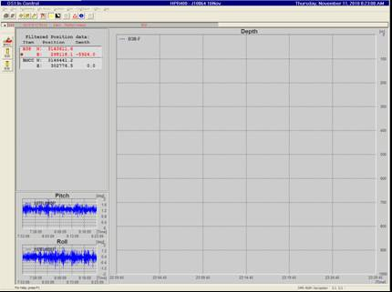
Figure 3. APOS’s working screen.

The main menu bar has 9 categories that can each be opened to reveal the different dialog boxes (commands) available. Below this menu bar is the speed toolbar which contains 11 buttons that provide shortcuts to the most used commands. There is also a column of transponder symbols to the left of the screen and a status bar at the bottom (Fig. 4 and 5).

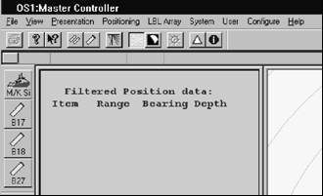
Figure 4. APOS’s main menu bar, speed toolbar and column of transponder symbols.

Figure 5. Status bar at the bottom of APOS’s window screen.

- THE WINFROG WORKING SCREENS

  - INTRODUCTION

The operator communicates with the WinFrog system through screens, a keyboard and mouse (trackball). The program uses menus, dialog boxes and windows. Two separate computer screens are used, that for the purpose of this manual will be addressed as WinFrog Screen-1 and 2. One is displayed only for the navigator and the other one is accessible to the vessel’s crew.

The Screen-1 window has the main menu bar, with 8 categories that can each be opened to reveal the different dialog boxes (commands) available. Below this menu bar is the speed toolbar which contains up to 36 buttons that provide shortcuts to the most used commands (Fig. 6).

Figure 6. The main menu bar and speed toolbar on WinFrog’s Screen-1.

  - THE WINFROG POSITION MAP SCREENS (GRAPHICS)

    - INTRODUCTION

The WinFrog program works with several position map screens, called Graphics screens, which show the location of different points of interest, like the vessel, active waypoint, beacon, etc. Each one can be opened, configured and controlled independently. For the company’s purposes, generally only two are needed, named Graphics-1 and 2. Figures 7 and 8 display the typical WinFrog working screens.

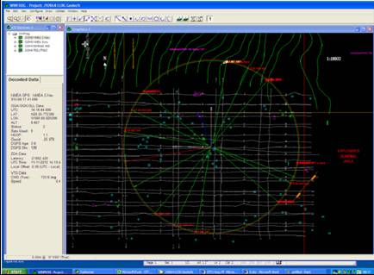
Figure 7. WinFrog’s Screen-1 displaying the Graphics-1 window, main menu bar and toolbar buttons.

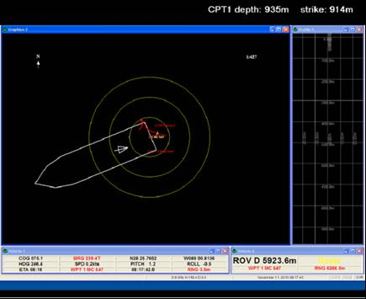
Figure 8. WinFrog’s Screen-2 displaying the top-black banner, Graphics-2, Profile-1, Vehicle-1 and 2 windows.

    - SOME TROUBLESHOOTING

- If the program’s screens are accidentally minimized→ Click on the top banner that says “WinFrog”.

- To create a new Graphics screen (if one is accidentally closed or a new one is needed):

- On the main menu bar→ View→ Graphics (Fig. 9)→ A new Graphics screen appears, with several grids displayed.

- Right click on the new screen→ Configure→ A “Configure Graphics” window will open→ Open the “Grids” tab→ Disenable the Projection and Geographic Grids→ OK. Reposition the new Graphics screen (Fig. 10).

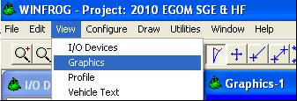
Figure 9. Creating a new Graphics screen in WinFrog.

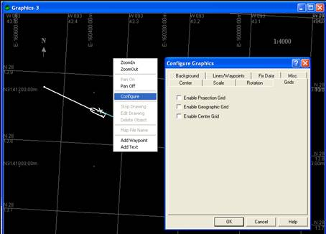
Figure 10. Configuring the grids on a new graphics screen in WinFrog.

  - THE WINFROG PROGRAM VEHICLES

    - INTRODUCTION

WinFrog allows the definition of a high number of vehicles for the purpose of real-time navigation, tracking and collection of data. These may be ROVs (ROV: stands for “remotely operated vehicles”), a vessel, or any other object related to navigation. Each one can be opened, configured and controlled independently.

Any number of vehicle text windows can be displayed on the WinFrog screen. If the window is Right clicked, it will display a list of available vehicles, which allows the navigator to select the vehicle whose information is wanted displayed in that particular window. For the company’s purposes, there will usually be a minimum of two vehicles configured in the WinFrog program, which are visually accessible for the vessel’s bridge and winchman and are located under the Graphics-2 screen (Fig. 11):

- The vessel or boat (Ex. GeoExplorer). Usually designated Vehicle-1.

- The USBL beacon vehicle that is lowered (the ROV). Usually designated Vehicle-2.

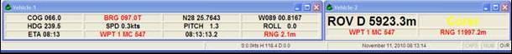
Figure 11. WinFrog’s Vehicle-1 and 2 windows.

    - DISPLAYED INFORMATION

The vehicles windows are an important source of information (Fig. 12) and can be configured to display different data points, of which the following are common:
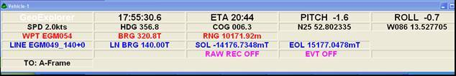Figure 12. WinFrog’s Vehicle-1 window displaying several information points.

- Waypoint (WPT): specifies the active waypoint (coring/data collection destination site). Ex: WPT EGM049

- Speed (SPD): specifies the vehicle’s speed Ex: SPD 2.0 kts

- The current time can also be displayed. Ex: 17:55:30.6

- Estimated Time of Arrival (ETA): an approximate calculation of the time the active site will be reached. Ex: ETA 20:44

- The coordinates: location of the waypoint. Ex: N25 52.802335, W086 13.527705

- The Range (RNG): it refers to the specific distance between a particular vehicle and the currently active waypoint. This range will be displayed for both the vessel’s vehicle and the beacon’s vehicle in their respective windows.

- The Heading (HDG): it refers to the current horizontal direction the bow of the vessel points or heads to in degrees (clockwise through 360°). Ex: HDG 356.8

- The Course Over Ground (COG; sometimes called Course Made Good): it indicates the true direction the vessel is moving towards in degrees (clockwise through 360°), which can be different from the heading. The difference between the HDG and the COG informs how much the vessel is “crabbing” (crab: to cause to move or scurry sideways or diagonally. Used in vessel maneuvering to compensate for drift; Fig. 13). Ex: COG 006.3

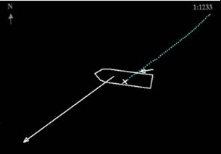
Figure 13. A WinFrog’s graphics screen displaying a vessel crabbing.

- The PITCH: it’s the plunge with alternate fall and rise of the bow and stern of the boat in open water (Fig. 14). The number displayed is the value of the intensity/direction of the vessel pitch in degrees (clockwise through 360°), as measured by a motion reference unit (MRU) and input into the WinFrog program. Ex: -1.6
- The ROLL: it’s the side to side rocking movement of the boat in open water (Fig. 14). The number displayed is the value of the intensity/direction of the vessel roll in degrees (clockwise through 360°), as measured by a motion reference unit (MRU) and input into the WinFrog program. Ex: -0.7

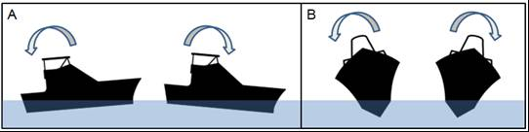
Figure 14. The vessel’s pitch (A) and roll (B) in open water.

If there is a survey line (for bottom tracking), the vehicle text windows may also display:

- The chirp line’s azimuth (bearing or heading). The bearing is the horizontal direction from one point to another on Earth in degrees (clockwise through 360°) from a direction of reference. Ex: LN BRG 140.00 T. It can also be specified under the survey line. Ex: EGM049_140+0, in which case the azimuth is 140°.

- The End of Line (EOL): refers to the distance from the vessel to the end of the currently tracked survey line. Ex: EOL 15177.0478 m

- The Start of Line (SOL): the distance from the vessel to the start of the currently tracked survey line. Ex. -14176.7348 mT

    - EDITING DISPLAYED INFORMATION

On the main menu bar, click on “Configure”:

- Vehicle Text→ A “Configure Vehicle” Text window will appear:

  - Under the “Available Items” box a selection can be made of the information that is displayed for each row

  - The text’s format can be changed. For example, the vessel’s bridge might need the row with the Speed and Heading to have a larger font than the other rows. Figures 15 and 16 show how the font size on Row 3 was increased for this purpose and the final result in the Vehicle’s text window.

This editing can also be done by Right clicking directly on the Vehicle screen of interest.

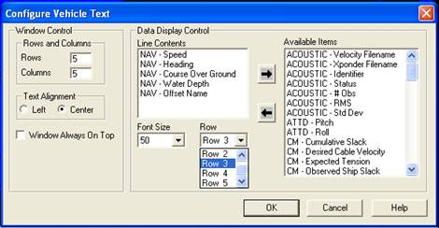
Figure 15. WinFrog’s “Configure Vehicle Text” window.

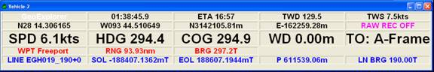
Figure 16. WinFrog’s Vehicle-2 window displaying different formats on its rows.

- The units for all distances displayed on all Vehicles should be in “meters” and not “nautical miles” (1 nautical mi = 1.15 mi = 1.85 km). Configure (main menu bar)→ Units→ A “Configure Units” window will open→ Select the “General” tab→ Select “meters” on the Distance and Waypoint boxes (Fig. 17).

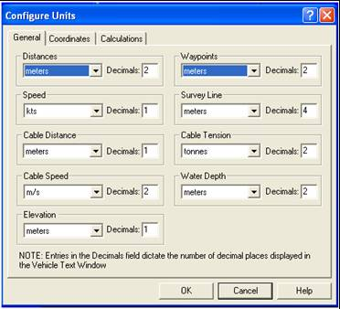
Figure 17. WinFrog’s “Configure Units” window.
    - SOME TROUBLESHOOTING

- When one of the WinFrog Vehicle text windows is maximized on the Graphics-2 screen, the entire screen turns gray. To undo this: close top banner→ Hit icon with double window→ Reactivate top banner by clicking on the short cut in the desktop.

- If one of the Vehicle screens is accidentally closed, on the main menu bar click on “Window”→ Select the Vehicle of interest. Reposition it in the correct screen (Fig. 18).

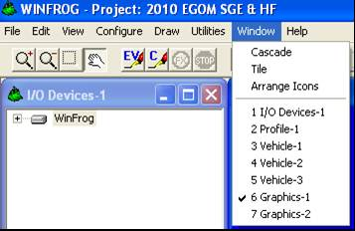
Figure 18. Opening a pre-existing vehicle window in WinFrog.

- THE DISCOVER SUB-BOTTOM PROGRAM SCREEN

  - INTRODUCTION

The operator communicates with the Discover Sub-Bottom system through a screen, keyboard and mouse (trackball). The screen is divided into three windows: 1) A small one on the top; 2) The Wave Form Display: a second small one on the bottom right side of the screen; 3) The Main Data Window: a large window on the bottom screen, which depicts the seabed and sub-seabed’s image.

The main menu bar has 4 categories that can each be opened to reveal the different accessible dialog boxes (commands). Below this menu bar is the speed toolbar which contains 13 buttons that provide shortcuts to the most used commands. Figure 19 shows the working screen used on the Discover Sub-Bottom program.

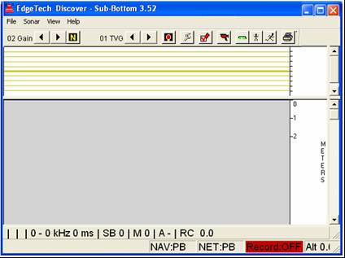
Figure 19. Discover Sub-Bottom’s working screen.

  - THE OSCILLOSCOPE WAVE FORM (ENVELOPE) DISPLAY

Called Wave Form display for short. It shows the depth scale and the amplitude of the signal as an X-Y plot of the sonar data received. A convenient way of adjusting the bottom tracker is via the scope display. It has several items, including (Fig. 20):

- Red Vertical Line: it indicates the current bottom track threshold. A left click is used to set the threshold.

- Green Horizontal Line: it indicates the current bottom track position (the bottom tracker). A left click is used to set the current bottom track position.

- Two Blue Horizontal Lines: they indicate the bottom track range (the search range). The left mouse bottom is pressed and dragged to select the bottom track range. Be careful not to disable the tracker by selecting only a very small area, which will set the track range to zero.

- Peaks are displayed after the depth scale, which are the reflections of the bottom image.

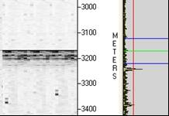
Figure 20. Section of the Discover Sub-Bottom’s Wave Form Display showing the bottom track threshold and range, bottom tracker and bottom reflections

SECTION 2:
GENERAL NAVIGATIONAL PROCEDURES

- SERVICES RENDERED BY THE NAVIGATION OPERATOR

  - GENERAL RESPONSIBILITIES

- Provide real-time, continuous ship track information for the purpose of vessel navigation between stations and proper occupation of the coring location during data/substrate collection.

The WinFrog position map screen available to the vessel’s crew (Usually Graphics-2) must always display the vessel, the active coring site and USBL beacon while coring. While in transit in between sites, it must display the vessel and the next active destination. Screens can be sized and centered using the “Spyglass”, “Square” and “Hand” toolbar buttons (Fig. 6).

NOTE: The Graphics-2 screen must be kept clear from open boxes used by the navigator for full visibility. They should be dragged to the Graphics-1 screen.

WARNING: The computers with the active APOS or WinFrog programs should never be moved or shifted, to prevent cables from loosening and the communication between them being jeopardized.

- Adjust the DGPS reference point on the vessel depending on whether the vessel is in transit or on station during coring.

- Create a digital report (CoreLog) for each core attempt, whether successful or not, registering the station designation, date, time, chirp line heading, wire depth and any other important details of the particular event (this will be addressed later in more detail).

- Create a Daily Progress Report (DPR) with the general information on the day’s accomplished work, including date, time, core attempts, transits, progress, weather conditions, etc.

  - FILLING OUT THE DAILY PROGRESS REPORT (DPR)

Navigators do not fill out the DPR but are required to keep a time log. The details of this timelog, who may access it and will is included will be discussed by the individual party chief on a job to job basis.

  - FILLING OUT THE NAVIGATION LOG

The Geographic Coordinator will provide a Navigation log for each project. His is an ever-changing spreadsheet and any details and questions must be communicated to the geographic coordinator. Cooperation with the lab and party chief is vital to the proper entry of the details of the nav log.

- GENERAL STEPS OF NAVIGATION OPERATION

  - INTRODUCTION

To avoids unnecessary repetition: the purpose of this part of Section 2 is to go through several steps in the process of core rigging that are shared in the three procedures described in this manual: CPT Singer Coring, Heat Flow Surveys and Geochemical Piston Coring (individual procedures covered in Sections 3-6). It will be indicated throughout this document when these common steps should be referred to and what point to go back to after that particular step has been carried out.

  - SETTING UP WINFROG WORKING FILES (CREATION OF WAYPOINTS)

    - INTRODUCTION

A waypoint is “a singular target or destination point”. It can be, for example, the target position for a place where data needs to be collected. Files used by WinFrog for data retrieval or storage are called Working Files. A Working Waypoints file is composed of a list of individual target points that can be displayed and tracked. Each waypoint has its own name, coordinates, etc. and is independent from other waypoints from these associated attributes.

    - PROCEDURE TO CREATE A WAYPOINT

NOTE: this procedure is usually carried out by the vessel’s party chief before the job starts and the “Working Waypoints” file is ready for the navigator to use.

            - Open the “File” tab from the main menu bar→ Edit Working Files→ Waypoints (Fig. 27).

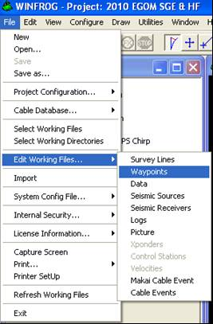
Figure 27. Instructions to add a new waypoint in WinFrog.

            - The “Working Waypoints” file will open (Fig. 28).

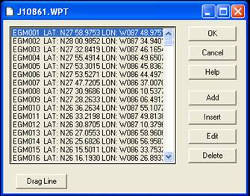
Figure 28. The “Working Waypoints” file in WinFrog, named after the job number.

            - Click on the “Add” button → The “Waypoint” window will open up (Fig. 29).

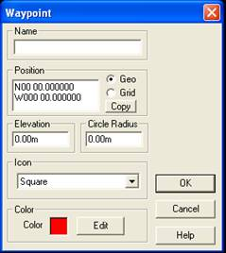
Figure 29. WinFrog’s “Waypoint” window.

            - Under “Name”, type the Waypoint’s specific code/name→ Highlight the data in the “Position” box→ Enter the waypoint’s coordinates. If “Grid” is selected, the coordinates can be entered as Northing and Easting→ Set the “Circle Radius” on 8 m→ The icon should be set on “Bulls-eye”→ In the color field, a specific color can be selected for the icon if desired→ OK (Fig. 30).

With this previous configuration, the symbol for each waypoint will be a Bulls-eye composed of three concentric circles, with the rings being 8 m apart from each other (Fig. 8).
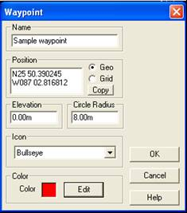
Figure 30. Filling out WinFrog’s “Waypoint” window to add a new site.

If referred to this step from:

- CPT coring: continue with step 2.2 of Section 3 (pg. 34).
- Geochemical coring: continue with step 2.2 of Section 4 (pg. 51).
- Heat flow survey: continue with step 2.2 of Section 5 (pg. 56).

  - EDITING WINFROG WORKING FILES (MODIFICATION OF WAYPOINTS)

To edit an existing waypoint in the Working Waypoints File:

      - From the “File” tab on the main menu bar: “Edit Working Files”→ Waypoints. WinFrog lists all the waypoints created previously in the “Working Waypoints” file. Right click on the waypoint to be edited (Fig. 31)→ Edit→ Make wanted changes→ OK (Fig. 32)→ If no more waypoints need modifying, click OK.

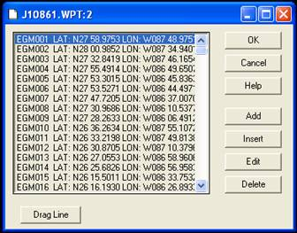
Figure 31. Editing a waypoint from WinFrog’s “Working Waypoints” File. This file is named after the job number.
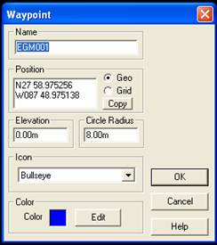
Figure 32. Editing a waypoint in WinFrog’s “Waypoint” window.

WARNING: For the company’s purposes, an existing waypoint file in WinFrog should never be modified. If a change needs to be made, copy the file (example of a file could be: J10864LLOG.wpt) to the projects directory where the DPRs are:

- Click on “Start” at bottom left of computer screen→ My network places→ Entire network→ Workgroup (might be under Microsoft Windows Network)→ Ship’s file server (might not be present)→ Projects. A second copy of the waypoint should be made in here and the end of the file should be modified from “.wpt” to “.csv”, so it can be opened using Excel (Fig. 33).

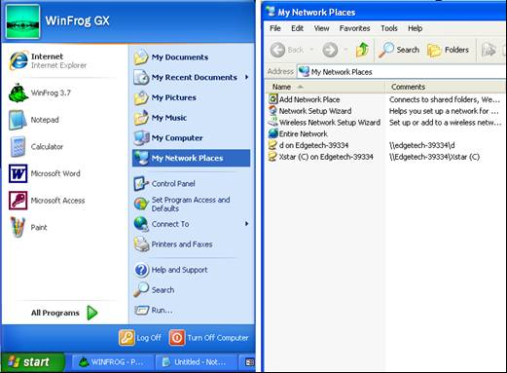
Figure 33. Site to save a modified WinFrog waypoint file.
  - SETTING UP WINFROG WAYPOINT TRACKING (ACTIVATION OF WAYPOINTS)

- On WinFrog, to select the next Waypoint→ Right click on the Vehicle Text Window→ Setup Waypoint Tracking (Fig. 34).

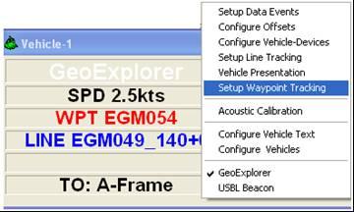
Figure 34. Setting up waypoint tracking on a vehicle window in WinFrog.

- A “Setup Waypoint Tracking” box opens→ Select “Waypoint File”. The dropdown menu on the left is used to choose the waypoint to be tracked from the “Working Waypoints” file (Fig. 35).

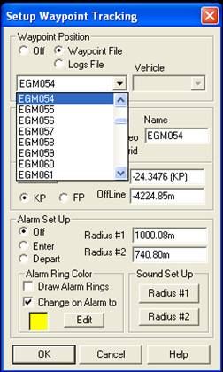
Figure 35. A “Setup Waypoint Tracking” window for a vehicle in WinFrog.

    - Each WinFrog vehicle window (the vessel, the USBL beacon and other vehicles if present) should be tracking the same waypoint. Set up Waypoint Tracking so all vehicles match.

    - When a location is active, the Bulls-eye turns yellow. When it is inactivated, it turns red (although the color can be modified). In some work sites, there are overlapping Bulls-eyes. To prevent confusion, the colors should be edited: Open the “File” tab on the main menu bar→ Edit working files→ Waypoints→ Locate the waypoint of interest→ Edit→ Select a dark purple→ OK.

    - A new waypoint is activated when the navigator obtains verification that good data/sediment recovery was successfully obtained from the current test site. Inform the vessel’s bridge when to head to new destination.

If referred to this step from:

- CPT coring: continue with step 2.3 of Section 3 (pg. 37).
- Geochemical coring: continue with step 2.3 of Section 4 (pg. 51).
- Heat flow survey: continue with step 2.3 of Section 5 (pg. 56).

  - TRACKING THE BEACON AFTER CORE RIG DEPLOYMENT

    - IN THE APOS PROGRAM

The following procedures must be carried out as soon as the barrel is submerged (Fig. 36):

          - Turn the beacon on: hit the button for the symbol of the deployed beacon (Example: B28 or B38 on Figure 36).

          - In the “Filtered Position data” window, under the speed toolbar, the lettering and dot will be red when the beacon is either turned off or has no signal. After it is turned on, the color should turn black and the dot green. If this doesn’t happen, the party chief must be informed.

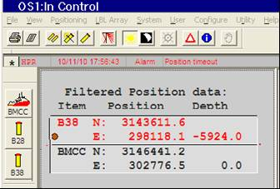
Figure 36. Section of APOS’s screen displaying the beacon symbols and “Filtered Position data” box.

          - The following must be verified: Right click on the Beacon’s icon on the top, left of the screen→ Interlog→ The interval should be set at 0.8

          - Peaks on the pitch should be monitored (Fig. 37). They should not reach more than 8º. The party chief must be informed if they are. It is problematic if the vessel’s pitch and roll is very strong, because it can interfere with the beacon’s signal.

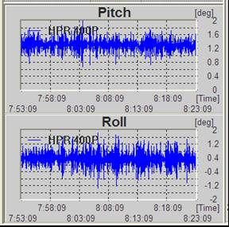
Figure 37. Section of APOS’s screen displaying the vessel’s pitch and roll.

    - IN THE WINFROG PROGRAM

  - The main target should be in the center of the screen. If not: Right Click on the Graphics-2 screen of WinFrog (one visible to crew)→ Configure→ Open the “Center” tab→ Select the “Center on Waypoint” button. The image should be expanded or contracted as necessary using the speed toolbar icons.

NOTES: be sure to select the correct, active waypoint from the scrawl down menu. It will not be automatically set to the active site.

  - If it is difficult for the vessel to stay on station after deployment: 1) The Graphics-1 screen should show the vessel, Bulls-eye and beacon; 2) Create a new Graphics screen:

- On the main menu bar→ View→ Graphics→ A new Graphics screen appears, with several grids displayed.

- Right click on the screen→ Configure→ A “Configure Graphics” window will open→ Open the “Grids” tab→ Disenable the Projection and Geographic Grids→ OK.

- Contract the new screen so it will show a close-up of the Bulls-eye and beacon. Place it on the top, right corner of Graphics-1 as displayed on Figure 38.

Another possibility, instead of creating a new graphics screen is to simply contract and reposition the Graphics-2 screen.
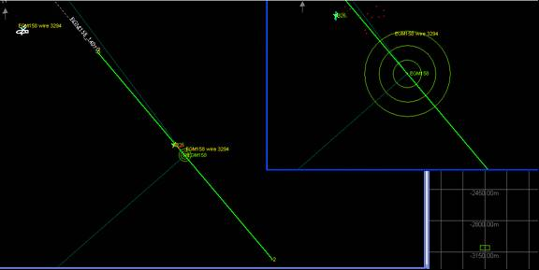
Figure 38. Appropriate positioning of WinFrog’s windows to clearly display the vessel, beacon and Bulls-eye.

    - BEACON SIGNAL TROUBLESHOOTING

With regards to the beacon’s signal, if:

- No signal detected as soon as the barrel hits the water:

After deployment, shortly after the beacon is turned on in APOS, the following must be monitored in WinFrog (Fig. 39):

                - Profile-1 graphics window: should show the yellow square that represents the beacon and it should be located appropriately in the screen as to depict the true depth in the scale.

                - Vehicle-2 (beacon’s) window: the “ROV” should display the correct estimated depth.

NOTE: the beacon depths in both windows must match each other (Fig. 39).

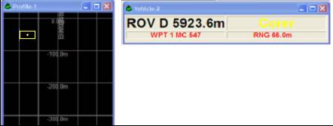
Figure 39. WinFrog’s Profile-1 and Vehicle-2 screens displaying accurate signal from the beacon.

If, from the beginning, the beacon has no signal at all:

              - Check that the Beacon’s vehicle text window is set on “Beacon” and not the vessel (Ex. GeoExplorer). Right click to make proper selection from popup window (Fig. 81).

              - Turn the beacon off in APOS (hit the beacon symbol; Fig. 36). Turn back on after a few seconds.

              - If there is still no response from the beacon, restart the APOS program.

WARNING: If the electric power goes down, APOS must always be restarted.

NOTE: the signal is usually lost if the beacon is buried in the sediment, when the barrel has reached bottom. Apart from this moment, the beacon should have signal at all times.

- Erratic behavior during trajectory or after strike: this implies that:

- It loses and regains signal in cycles.

- Inaccurate depths are being displayed (for example, if it’s about 3000 m deep, but a distance of say 200 m is being registered). In this case, momentarily turn beacon off in APOS (hit the beacon symbol; Fig. 36). Monitor its behavior.

WARNING: if it has signal, the beacon should be turned off only when incorrect depths are displayed. Otherwise, it must be kept on at all times!
- The cross symbol that signals the position of the beacon in the Bulls-eye is unstable and swaying.

The behavior of the beacon’s signal must be periodically checked both in APOS and WinFrog during its trajectory. Record if it’s erratic on: 1) The DPR; 2) The Corelog Database on WinFrog; 3) The F10 Manual Event printout created after strike.

If referred to this step from:

- CPT coring: continue with step 3.2 of Section 3 (pg. 41).
- Geochemical coring: continue with step 4.2 of Section 6 (pg. 75).
- Heat flow survey: continue with step 4.2 of Section 6 (pg. 75).

SECTION 3:
CPT STINGER CORING

- INTRODUCTION

A CPT Stinger is a Deep Water Static Core Penetrometer developed by TDI-Brooks. It is used in tandem with a Jumbo Piston Coring (JPC) rig to push a cone penetrometer up to 16 more meters beneath the nose of the embedded JPC. In consequence, in-situ CPT data can be acquired from almost double the depth of that possible just with the JPC.

- PROCEDURES TO FOLLOW BEFORE REACHING THE ACTIVE WAYPOINT

  - SETTING UP WINFROG WORKING FILES (CREATION OF WAYPOINTS)

Follow the procedure described on step 2.2.2 of Section 2 (pg. 25).

  - SETTING UP WINFROG WAYPOINT TRACKING (ACTIVATION OF WAYPOINTS)

    - FOR SITES CORED FOR THE FIRST TIME

If no core rigs have ever been deployed in a particular site, follow the procedure described on step 2.4 of Section 2 (pg. 29).

    - FOR PREVIOUSLY TESTED SITES

Some coring locations need to be tested several times, like when CPTs with both a long and short barrels must be deployed. If a site has been tested before because of previous coring activity, then the selected site within the Bulls-eye for the next deployment must not be too close from the previous one:

  - Open the “File” tab on the main menu bar→ Edit working file→ Waypoints→ Add new→ Name the sample and specify if it’s a long or short CPT (if applicable)→ Type in the coordinates obtained from the Position Averaging Report (PAR), under “Height”, or from the Excel file displaying the CPT settings. The strike distance is 20 m shorter than the total length (Fig. 40 and 59)→ Copy the coordinates→ OK→ OK.

A possible destination of that Excel sheet is: Click on Start at bottom left of computer screen→ My network places→ Entire network→ Microsoft windows network→ Workgroup→ Bbb (Bernie Bernard’s computer)→ Stinger Settings and data→ CPT settings 2010.xls (look for current year and project) (Fig. 40).

NOTE: a comment is added on the core name with the date the coring was performed. Left click on specific core ID→ Insert comment (Fig. 41).

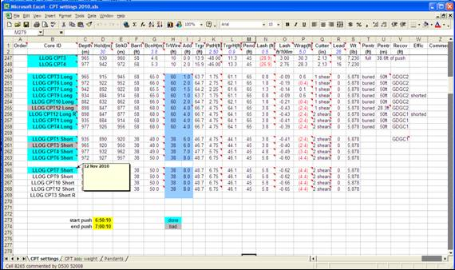
Figure 40. Excel file showing the CPT settings.

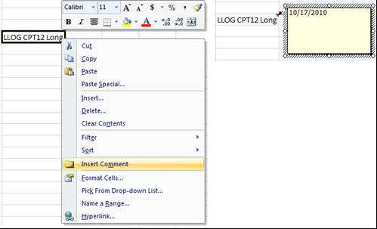
Figure 41. Adding a site’s coring date on the Excel CPT Settings file.

  - Still on the “Waypoints” window→ Add new→ Paste the coordinates. To avoid the area of sediment that has been previously tested, the third decimal of the coordinates for the latitude must be changed by 3-4 units (Example, from N28 25.5941 to N28 25.5971): 1) If they are subtracted, the new waypoint will be below the ones previously tested; 2) If they are added, it will be above. To avoid confusion for the vessel’s bridge, add “drop here” or “put here” to the CPT’s name, so the ship’s proper positioning will be clear. Hit OK→ OK (Fig. 42).

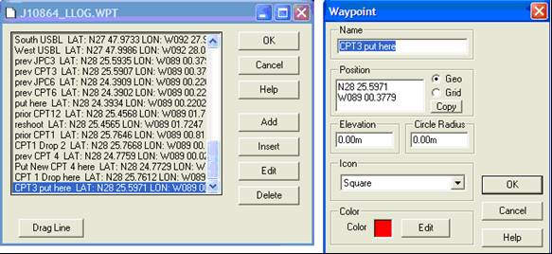
Figure 42. In WinFrog, adding another coring location in a previously tested site.

The Bulls-eye screen should be checked, to verify that the new deployment site lies within the inner circle. If too close to the edge, the third decimal on the coordinates should be changed one unit at a time until an acceptable location is achieved (Fig. 43).

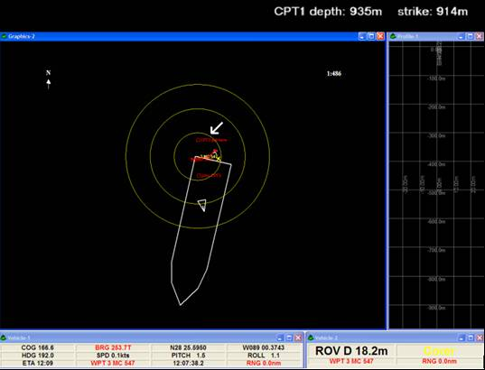
Figure 43. WinFrog Bulls-eye with several deployment sites. Note that the active testing location was specified by adding “put here” to the name of the CPT and it is positioned appropriately within the Bulls-eye.
  - SETTING UP THE TOP-BLACK BANNER

A top-black banner might be configured and placed over the Graphics-2 screen of WinFrog, which normally displays the job title, CPT depth and strike distances (Fig. 43). By double left clicking on the banner, this information can be edited. The amount of time the barrel stays buried in sediment depends on the barrel size: 1) For a short one, it’s 10 min; 2) For long one, it’s 15 min (this time is referred to as “logging time”). This is specified under “Use Countdown”. Click on save and collapse.

NOTES:

- If the program has been closed, the timer will default to 15 min and must be changed if a short CPT is being performed.

- When the top-black banner is not available for information display: on the WinFrog computer, under “All Programs”→ Accessories→ Notepad. Include: 1) The Core’s ID; 2) Depth; 3) Time it hit: 4) Time it must be retrieved (10 or 15 min depending on the barrel length). Fill out the information for the events as they happen. Place on top, left corner of the Graphics-2 screen for the vessel’s bridge and winchman (Fig. 44 and 45).

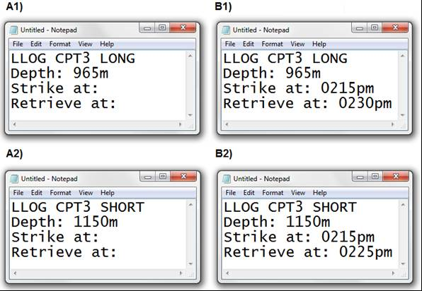
Figure 44. Notepads for CPT coring with core information for winchman and bridge: A1&A2) Preliminary ones ready before strike for long and short barrels; B1&B2) Filled out ones after strike for long and short barrels.

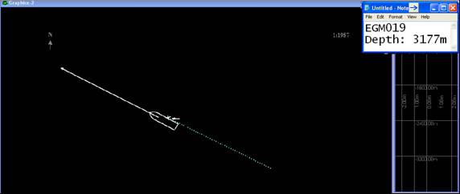
Figure 45. Proper positioning of Notepad with core information for winchman and bridge on WinFrog’s Screen 2.

  - SETTING UP THE BEACON’S PROFILE-1 GRAPHICS SCREEN

    - INTRODUCTION

A Graphics screen, usually named Profile-1, might be present to the left of the Graphics-2 position map screen (Fig. 43). It has the Projection and Geographic grids enabled, for its purpose is solely to track the progression of the beacon’s position, as it’s being lowered or retrieved. The beacon is represented by a small yellow box with a cross in the center (Fig. 46).

    - CREATING A NEW SURVEY LINE FOR BEACON TRACKING

- Right click on the text window of a WinFrog vehicle→ Setup Waypoint Tracking→ Copy coordinates.

- Right click on the Profile-1 screen window:

- Configure Profile→ On the “Vehicle” box change to “Corer” (note that when opening the “Configure Profile” window, the options that appear may vary).

- Configure Profile→ Click on the “Position” tab→ Select “Fixed”→ Paste coordinates (Fig. 46). A teal line will appear on the Bulls-eye. Re-open and Modify the first decimal of longitude coordinates (westward) by 1/10 (it is irrelevant if by subtraction or addition of one unit). This changes the position of the teal line so it will not block the site.

NOTE: as it was specified before, the creation of this survey line is for beacon tracking only and not for the purpose of sub-bottom image recording (as used in Section 6). This is why it is moved away from the Bulls-eye.

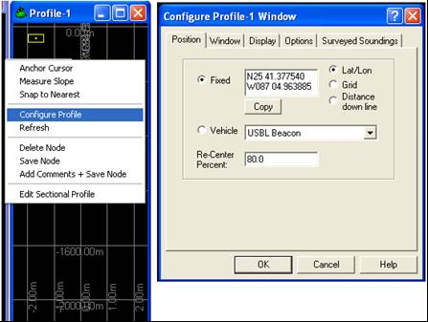
Figure 46. Creating a survey line for beacon tracking in WinFrog.

    - SCALE ADJUSTMENTS

The scale on the screen must be adjusted so it will show the entire trajectory of the beacon, which varies according to the depth the seabed is at: Right click on the Profile-1 screen→ Configure Profile→ A “Configure Profile” window will open→ Click on the “Window” tab (Fig. 47)→ Change total vertical range to at least 1000 m more than estimated total depth estimated for the site→ OK.

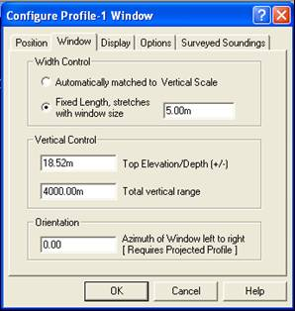
Figure 47. WinFrog’s “Configure Profile-1” window.
  - CONFIGURING OFFSETS

Click on WinFrog’s Vehicle-1 text window→ A “Configure Offsets” window will appear→ Click on the “A-frame” button (Fig. 48)→ OK.

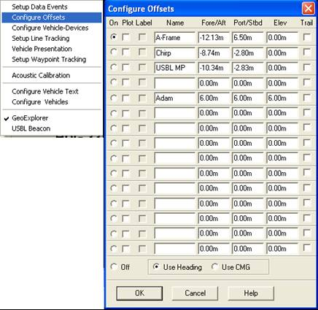
Figure 48. WinFrog’s “Configure Offsets” window set on the “A-frame”.

The setting on the Vehicle-1 text window will change to “A-Frame”. This will move the DGPS transponder fix to the A-frame of the vessel. The stern indicator of the boat will then show on the WinFrog Graphics screen (depicted as a small cross that shows where the barrel would be deployed) (Fig. 49).

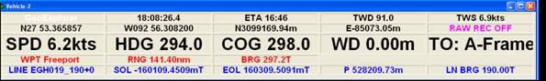
Figure 49. Vehicle settings configured on the vessel’s A-frame.

- PROCEDURES TO FOLLOW ON STATION

On the DPR, record the time of deployment of the core rig. If for some reason, the exact time is missed it can be mathematically calculated: the barrel travels at about 22 m/min; so the total distance traveled should be divided by 22 and the result subtracted from the time the barrel struck.
  - TRACKING THE BEACON AFTER CORE RIG DEPLOYMENT

Follow the procedure described on step 2.5 of Section 2 (pg. 30).

  - PREPARATION FOR STRIKE

    - MANUAL EVENT 100 m BEFORE THE STRIKE DISTANCE

One hundred meters before reaching the strike distance (120 m before total depth):

  - Click on the Graphics-2 screen (to activate it) and hit the keyboard’s F10 button immediately→ A “Manual Event” window will open→ In the “Comment” box the event can be named RF (reference point), or the name of the core followed by an underscore and the azimuth (EX: EGM017_300)→ OK. A printout will be produced and a mark will appear on the screen showing where the estimated location of the barrel’s burial will be (used for later tracking purposes). The importance of this will be further addressed (Fig. 50).
.
TROUBLESHOOTING: If pressing the F10 button does not open the “Manual Event” window:

- Check the bottom screen of WinFrog to see if there is another window that needs to be closed (the program does not allow more than one popup window to be active at a time).

- Make sure the Graphics-2 screen was the one active (because the Manual Event can’t recorded on it if it’s not so). That is the reason it has to be selected before hitting F10.

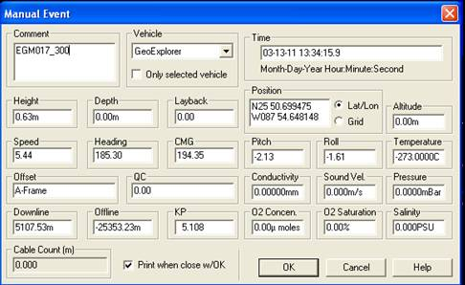
Figure 50. WinFrog’s F10 “Manual Event” window.

  - From WinFrog’s main menu bar click on “Utilities”→ Select “Position Averaging”→ The “Position Averaging” window will open.

The values selected for “Average interval” and “Total average time” determine how often data measurements will be taken (in seconds) and for how long the data recording will take place (in minutes), so:

- If total depth is known: select “2” for “Total average time”→ Select “5” for “Average Interval” (Fig. 51).

- If total depth is unknown: select “5” for “Total average time”→ Select “15” for “Average Interval”.

    - LOGGING DATA 20 m BEFORE STRIKE DISTANCE

- Hit “Start” on the “Position Averaging” window 20 m before the strike distance. Once this is done, blue bars start appearing underneath the button and data recording will commence (Fig. 52).

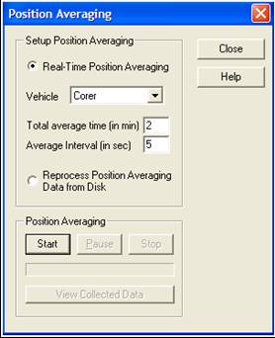
Figure 51. Format for WinFrog’s “Position Averaging” window when total depth is known.

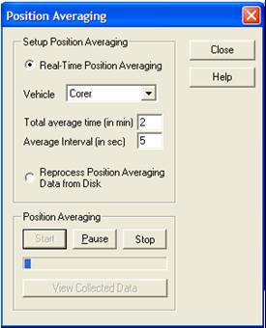
Figure 52. WinFrog’s “Position Averaging” window actively logging data.

- Keep track of the data logging time left: if the total depth value was greater than that expected, logging time can run out before the barrel hit’s bottom (space almost filled with the blue bars). In such a case, immediately hit “Stop” and restart the logging.

- Underneath WinFrog’s speed toolbar, all four icons under the the I/O Devices-1 window should be green (Fig. 53).

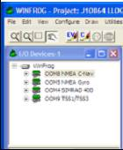
Figure 53. WinFrog’s I/O Devices-1 window with all green icons.

  - STRIKE OF BARREL

    - INITIAL STEPS

As soon as the barrel strikes, close tracking of the beacon’s signal must be kept in the APOS screen. If the likely event of the beacon losing signal occurs (letters and dot turn red again on the top-left of APOS, next to the beacon symbols), five things need to be done immediately:

- Record the depth at which the barrel struck. This value is later compared with the one registered at retrieval.

- Record the exact time (hour, minutes and seconds) that the beacon lost signal. This will be further needed for data selection.

- Hit “Stop” on the “Position Averaging” window.

- On WinFrog’s top-black banner: 1) Double verify that the logging time set is for the appropriate barrel size: 10 min for short, 15 min for long); 2) Hit “Mark on bottom” to start timer.

NOTE: if the black banner is not available, use the Notepad (Fig. 44).

- Use walkie-talkie to inform crew that the barrel struck (if whinchman doesn’t).

    - THE POSSIBILITY OF OBTAINING PRIMARY DATA

Logging data while the barrel is being lowered is done as a backup, in case signal is lost when the barrel is buried. If the beacon does not lose signal, or regains good signal after strike, the possibility of collecting excellent/primary data exists. The logging of this primary data can be done if the following conditions are met after strike, on WinFrog’s Graphics-2 screen:

- Beacon still has signal or regains and maintains it (it should not turn on and off in cycles).

- The cross symbol that signals the position of the beacon in the Bulls-eye is stable (not swaying).

- The correct depth is being displayed (beacon is not lost). If the beacon is lost (for example, if it’s about 3000 m deep, but a distance of say 200 m is being registered) it should be momentarily turned off and it’s behavior monitored.

WARNING: if it has signal, the beacon should be turned off only when incorrect depths are displayed. Otherwise, it must be kept on at all times!
- The boat is still in the position it had during deployment (not swaying). The Reference Point created with the “F10 Manual Event” is used for this purpose: Right Click on the Graphics-2 screen→ Configure→ A “Configure Graphics” window will open→ Click on the “Fix data” tab→ Click on “Plot Log Files”→ OK (Fig. 54).

If the previous conditions are met: hit the “Start” button on the “Position Averaging” window. It is ideal to obtain 1-2 min of data. The measurements taken during descent are erased, but again, this is just backup information.

NOTES:

- Do not save backup data if recording of primary data will take place, to avoid later confusion with the files.

- If beacon signal is lost during this primary logging, register the exact time (hour, minutes and seconds) this event happens and hit “Stop” on the “Position Averaging” window.

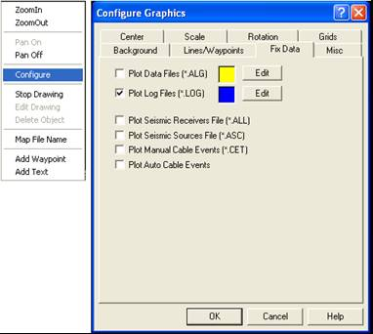
Figure 54. WinFrog’s “Configure Graphics” screen set to “Plot Log files”.

As will be discussed later in more detail, if no data was collected previous or after strike (for example, if the seabed was expected to be deeper and the barrel struck prematurely and no signal was available while buried), then the navigator must be ready to log data after retrieval. Calculate correct strike distance (20 m before actual seabed depth), which will be used as a reference point.
  - BARREL RETRIEVAL

    - INITIAL STEPS

- After logging time is up, the order is given by the navigator to retrieve the barrel.

- As soon as signal is regained:

- Record the depth registered at retrieval: which should be similar to the one recorded on the PAR that will be later produced. If it’s not, proper adjustments must be made that will be further discussed.

- If no data was collected previous or after strike, commence data logging. Data recording should be stopped at 20 m after the correct strike distance is reached. Proper corrections must be made on the the Excel file for total depth and strike distance.

    - SCREEN CAPTURE 20 m AFTER STRIKE DISTANCE IS PASSED

Around 20 m after strike point, click on the APOS screen with the depth diagram to activate it (Fig. 55)→ Simultaneously hit the “Alt + Print screen” buttons on the keyboard→ Open “Paint” under the computer’s “Accessories”→ Paste. Click on “Save As”→ Computer’s C drive→ APOS→ Data→ Select the correct job number→ Screen Captures→ Click on a previously existing file and modify the name, so it will have the proper format and end in “.bmp”. If it’s a reshoot, it must be specified in the name. This will provide an image showing that the rising barrel.

WARNING: care must be taken as to not over-write a pre-existing screen capture.

TROUBLESHOOTING: if the section on the APOS screen that shows the graph with the progress of the beacon is not visible: Right click on it→ Select Numeric View.

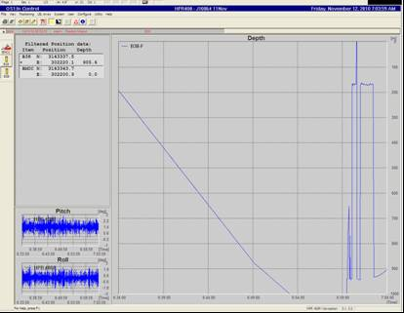
Figure 55. APOS screen displaying the beacon’s trajectory.
  - THE POSITION AVERAGING REPORT (PAR)

On the “Position Averaging” window click on “View Collected Data”→ The “Position Average for Corer” window will open up.

- On the “Observed Data” box:

- Scrawl to the right to display the “Time” column of the data points.

- Access the record of the exact time the barrel lost signal. The measurements taken after this moment mustn’t be used on the record. For example, if it hit at 17:42:01, then the data after that time is incorrect (Fig. 56).

NOTE: if logging of primary data occurred without beacon signal loss or it was obtained after barrel retrieval, then no data points are incorrect and the file is saved as it is.

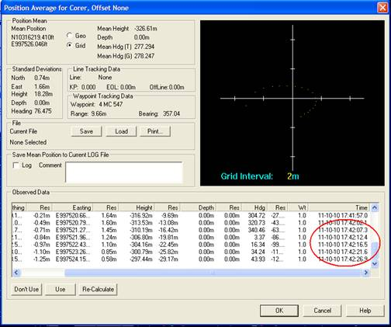
Figure 56. WinFrog’s “Position Average for Corer” window showing measurements that must be inactivated according to the time they were logged.

- Scrawl back to the left, highlight the “Y” on the data points that need to be eliminated→ Click on “Don’t Use”. They will change to “N”→ Re-Calculate (Fig. 57).

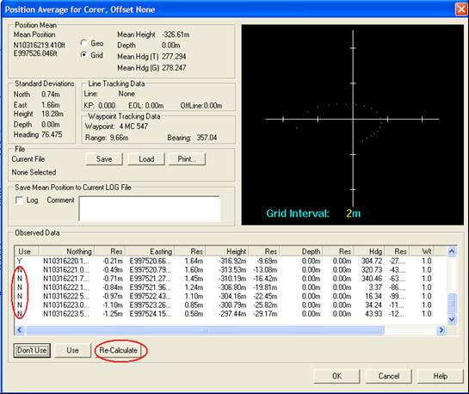
Figure 57. Inactivating erroneous measurements on WinFrog’s “Position Average for Corer” window.

- “Position Average for Corer” window→ On the “File” box in the middle of the window hit “Save”→ The “Select Position File” window will open (Fig. 58)→ Click on a previously existing file and modify it, so it will be named with the proper format and ending in “.aep”. If it’s a reshoot, it must be specified in the name→ Save.

WARNING: care must be taken as to not over-write a pre-existing file.

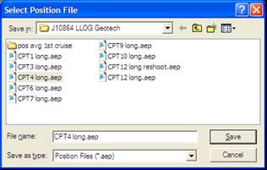
Figure 58. WinFrog’s “Select Position File” window.
- “Position Average for Corer” window→ On the “File” box in the middle of the window hit “Print”→ The “Position Averaging Printing” window will open→ Browse→ Look for correct job number→ Click on a previously existing file and modify it, so it will be named under the proper format and ending in “.rft”. If it’s a reshoot, it must be specified in the name (Fig. 59).

WARNING: care must be taken as to not over-write a pre-existing file.

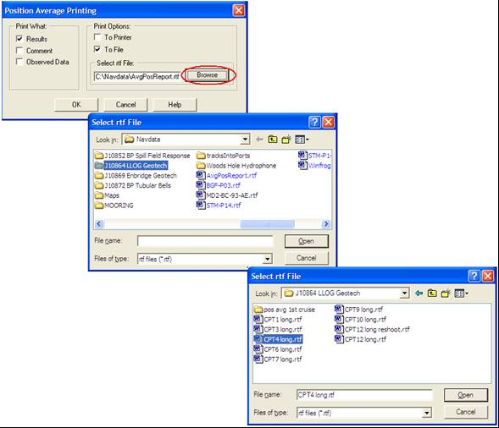
Figure 59. Creating the “rft.” file for the Position Averaging Report (PAR) in WinFrog.

- Go to My computer→ Open the C drive→ NavData→ Select the correct job number→ Find the current’s CPT file→ retrieved the registered retrieval depth. Compare to the one displayed on the PAR under “Height” (Fig. 60). If they are significantly different, the correction must be made on the report before printing, making sure that one decimal is kept followed by “on pull out” typed next to it→ Print two copies. A copy is given to the Client Representative and the second one is placed in the correct job binder under “NavLogs”.

WARNING: never create a file on NavData in the computer’s C drive.

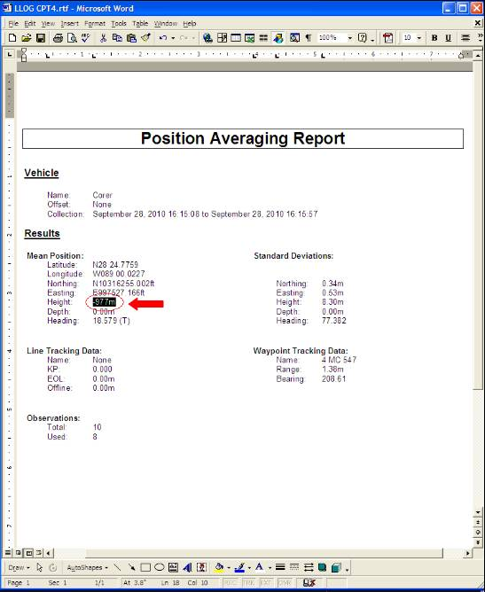
Figure 60. A Position Averaging Report (PAR) on WinFrog.

- To close the “Position Average for Corer” window hit OK. A window with a warning will appear which can be safely ignored.

  - BEFORE BARREL IS BACK ON DECK

Activate the next destination (waypoint) and request the vessel’s bridge to wait for confirmation of successful data recovery before heading to new site.
  - AFTER FULL BARREL RETRIEVAL

    - VERIFICATION OF ACQUISITION OF GOOD DATA

On the DPR, record the time the core rig is back on deck.

Data obtained can now be viewed. After there has been a confirmation of good data being obtained:

    - Request the vessel’s bridge to head to new destination.

    - In the “CPT settings” Excel sheet, highlight the name of site in teal. If it’s a reshoot, highlight in gray. Add a comment with the date. A blank row is left in between cores performed on different days.

    - Fix the coordinates: the Excel sheet has the coordinates where the data would have been ideally taken from, which is different from the site where the logging actually took place. The “Range” on the PAR specifies how far from the target the strike site was.

Open the “File” tab on WinFrog’s main menu bar→ Edit working file→ Waypoints→ Click on the file named “put there” (the Manual Event) and, using the data from the PAR, fix to accurate coordinates. Include the Range on the DPR as well.

    - The information from the PAR has to go into the appropriate “CPT-Stinger Positions” file in Excel. This data must not be copy/pasted from the PAR, it has to be typed.

    - BARREL ON DECK

On the DPR record:

- The time the core rig has been retrieved and is on deck.

- The transit time in between core rigs.

This finalizes the procedures for this CPT event.

SECTION 4:
PRELIMINARY GEOCHEMICAL PISTON CORING PROCEDURES

- INTRODUCTION

Hydrocarbons from deep reservoirs that have migrated upward can be detected in sediments near the surface via Surface Geochemical Exploration (SGE). These geophysical surveys are used to select petroleum coring sites based on the surface behavior of faults and other attributes. For these studies, TDI-Brooks uses a piston coring rig to obtain up to 9 m of ocean sediment samples in water depths of up to 4,000 m.

Geochemical studies go hand in hand with heat flow surveys to assess fault and structural seals. This alliance creates a better knowledge of an areas hydrodynamics and occurrence of hydrocarbons.

- PROCEDURES TO FOLLOW BEFORE REACHING THE ACTIVE WAYPOINT

  - SETTING UP WINFROG WORKING FILES (CREATION OF WAYPOINTS)

Follow the procedure described on step 2.2.2 of Section 2 (pg. 25).

  - SETTING UP WINFROG WAYPOINT TRACKING (ACTIVATION OF WAYPOINTS)

Follow the procedure described on step 2.4 of Section 2 (pg. 29).

  - CREATING A NEW SURVEY (CHIRP) LINE FOR SUB-BOTTOM IMAGE RECORDING

- Click on “File” from the main menu bar→ Edit Working files→ Waypoints→ The “Working Waypoints” window will open→ Double click on the waypoint of interest that requires a chirp line. Highlight the coordinates on the “Position” box→ Copy→ Hit Cancel (Fig. 61).

WARNING: care must be taken as to not accidentally alter the waypoint’s coordinates.

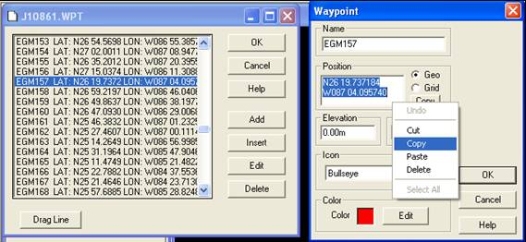
Figure 61. The “Working Waypoints” and “Waypoint” windows in WinFrog.

- Open the File tab on the main menu bar→ Edit Working Files→ Survey lines. A “Survey line” window will open (Fig. 62)→ Calculate Grid→ A “Preplot Grid” window will open→ highlight the blank coordinates in the “Grid Center/Orientation” box→ Left click and paste.

The Azimuth (chirp line heading or direction) is chosen such that the vessel is: 1) Moving down seas and not against currents; 2) Crabbing a few degrees to port or starboard. The navigator must communicate with the vessel’s bridge to know the sea’s direction.

Under the “North/South Line” box set the following (Fig. 62):
- Number of lines: 1 (one)
- Length of line: 1000 m
- Spacing: 0 (zero)
- Name prefix: must be the name of the core with an underscore and the line heading (azimuth). Ex: if the chirp line for EGM006 has a heading of 290°, the name prefix should be EGM006_290.
- Click on OK→ OK. This closes the window. A solid line will appear that runs across the waypoint. Figure 63 depicts a Bulls-eye with a green survey line configured.

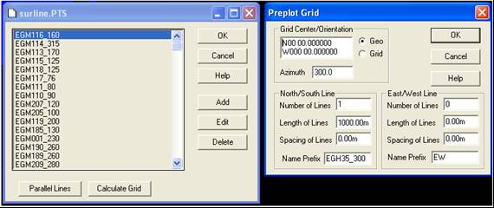
Figure 62. WinFrog’s “Surline” and “Preplot Grid” windows with proper setup for geochemical coring.

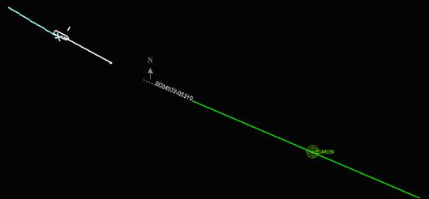
Figure 63. Bulls-eye with a green “survey line” and white “line tracking” configured in WinFrog.
- On WinFrog, Right click on the Vehicle-1 text window→ Setup Line Tracking→ “Setup Line Tracking” window will open (Fig. 64)→ Select the survey line created before from the drop down menu→ Confirm that the “Forward” button is selected→ The “Graphics Extension” box defines the white, dashed line that leads into the chirp line (called “line tracking”) and is used by the vessel’s bridge to get the boat properly positioned to run it. If weather and/or sea current conditions are relatively calm, select 200 m as the “Length” of the “Graphics Extension”. In rough sea conditions, choose 400 m→ Hit OK to close window.

NOTE: Ignore the pop up message shown on Figure 65 and hit OK.

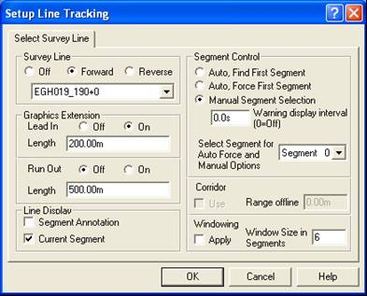
Figure 64. WinFrog’s “Setup Line Tracking” window with setup for geochemical coring.

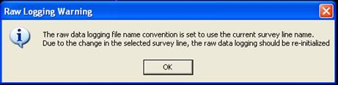
Figure 65. WinFrog’s “Raw Logging Warning” window.

The line tracking will appear on one end of the chirp line. The vessel will approach the chirp line from this dotted end (Fig. 63).

TROUBLESHOOTING: the "Setup Line Tracking" window will not open if:

  - The FX (Start) button on the speed toolbar is still active. Hit Stop.

  - Click on “Configure” in the main menu bar→ Data Events→ Setup→ An “Event Configuration” window will open. On the Event Start box click on “Off” (at this point, the “Manual Start” button should not be active)→ Hit OK. The “Event Configuration” window can also be opened by right clicking on the Vehicle’s window.
  - WINFROG DATA EVENTS SETUP (FOR AUTOMATIC FIX MARKS IN CHIRP SOFTWARE)

To set up the manual start for the chirp:

- On the top, left of WinFrog, under the main menu bar, the Start (FX) and Stop buttons are usually inactive (Fig. 66).

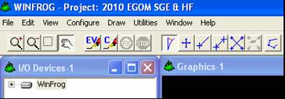
Figure 66. Inactive “Start” (FX) and “Stop” buttons for the chirp in WinFrog.

- Right click on the Vehicle-1 text window→ Setup Data Events. An “Event Configuration” window will open (Fig. 67). Another way of doing this is by clicking on “Configure” in the main menu bar→ Data Events→ Setup. Confirm that the “Interval” on the “Trigger” box is set on 500 m. On the “Event Start” box, click on the “Manual Start” button→ Hit OK.

A “Distance Fixing” window will appear (Fig. 68)→ Ignore it and hit OK.

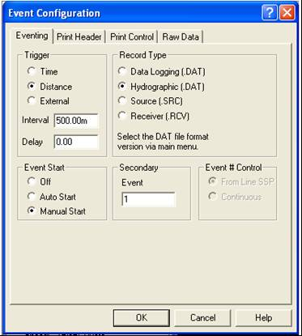
Figure 67. WinFrog’s “Event Configuration” window with proper setup for geochemical coring chirping.

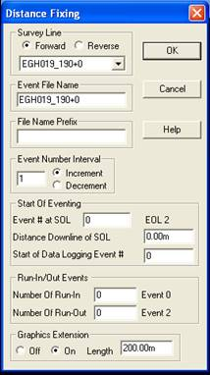
Figure 68. WinFrog’s “Distance Fixing” window.

These Data Events will be later activated on WinFrog. While they are, the program will automatically send a “fix” or event mark to the Chirp system on Discovery for every 500 m traveled down the selected survey line. These three fixes are composed of vertical, dashed lines that appear on the recorded chirp image of the sub-seabed. The first mark depicts the start of the line (0 m down line), the second one indicates the middle of the core location (500 m down line) or bulls-eye and the third fix shows the end of the survey line (1000 m down line).

- Three consecutive warning windows will appear (Fig. 69)→ Click Yes on all.

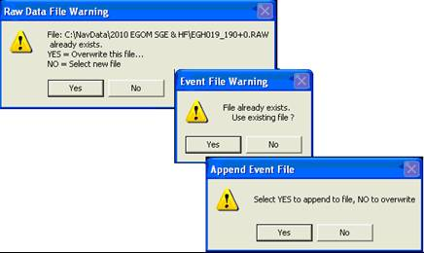
Figure 69. WinFrog warning windows.
SECTION 5:
PRELIMINARY HEAT FLOW SURVEY PROCEDURES

- INTRODUCTION

The research of sediment thermal conductivity and heat flow equilibrium are vital in the determination of regional scale maturation of basins with regards to gas and oil. Heat flow surveys also provide data on fluid flow from faults, lineaments and other surrounding structures. TDI-Brooks performs these surveys in depths of up to 6000 m. A probe that measures sediment temperatures, in-situ thermal conductivity and creates profiles of the water’s temperature is used.

Heat flow surveys go hand in hand with geochemical studies to assess fault and structural seals. This alliance creates a better knowledge of an areas hydrodynamics and occurrence of hydrocarbons.

- PROCEDURES TO FOLLOW BEFORE REACHING THE ACTIVE WAYPOINT

  - SETTING UP WINFROG WORKING FILES (CREATION OF WAYPOINTS)

Follow the procedure described on step 2.2.2 of Section 2 (pg. 25).

  - SETTING UP WINFROG WAYPOINT TRACKING (ACTIVATION OF WAYPOINTS)

Follow the procedure described on step 2.4 of Section 2 (pg. 29).

  - CREATING A NEW SURVEY (CHIRP) LINE FOR SUB-BOTTOM IMAGE RECORDING

- Click on “File” from the main menu bar→ Edit Working files→ Waypoints→ The “Working Waypoints” window will open→ Double click on the waypoint of interest that requires a chirp line. Highlight the coordinates on the “Position” box→ Copy→ Hit Cancel (Fig. 70).

WARNING: care must be taken as to not accidentally alter the waypoint’s coordinates.

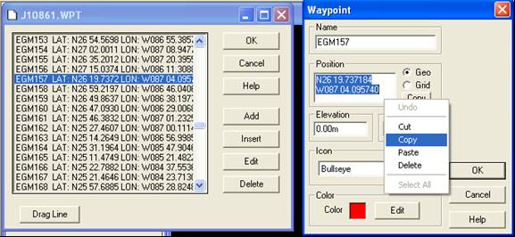
Figure 70. The “Working Waypoints” and “Waypoint” windows in WinFrog

- Open the File tab on the main menu bar→ Edit Working Files→ Survey lines. A “Survey line” window will open (Fig. 71)→ Calculate Grid→ A “Preplot Grid” window will open→ highlight the blank coordinates in the “Grid Center/Orientation” box→ Left click and paste.

The Azimuth (chirp line heading or direction) is chosen such that the vessel is: 1) Moving down seas and not against currents; 2) Crabbing a few degrees to port or starboard. The navigator must communicate with the vessel’s bridge to know the sea’s direction.

Under the “North/South Line” box set the following (Fig. 71):
- Number of lines: 1 (one)
- Length of line: 200 m
- Spacing: 0 (zero)
- Name prefix: must be the name of the core with an underscore and the line heading (azimuth). Ex: if the chirp line for EGH35 has a heading of 300°, the name prefix should be EGH35_300.
- Click on OK→ OK. This closes the window. A solid line will appear that runs across the waypoint. Figure 72 depicts a Bulls-eye with a green survey line configured.

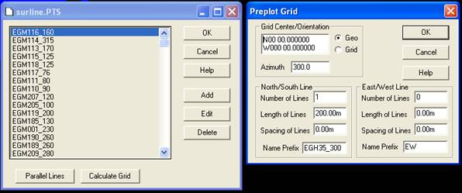
Figure 71. WinFrog’s “Surline” and “Preplot Grid” windows with proper setup for heat flow surveying.

Figure 72. Bulls-eye with a green “survey line” and white “line tracking” configured in WinFrog.
- On WinFrog, Right click on the Vehicle text window → Setup Line Tracking→ A “Setup Line Tracking” window will open (Fig. 73)→ Select the survey line created before from the drop down menu→ Confirm that the “Forward” button is selected→ The “Graphics Extension” box defines the white, dashed line that leads into the chirp line (called “line tracking”) and is used by the vessel’s bridge to get the boat properly positioned to run it. If weather and/or sea current conditions are relatively calm, select 100 m as the “Length” of the “Graphics Extension”. In rough sea conditions, choose 200 m→ Hit OK to close window.

NOTE: Ignore the pop up message shown on Figure 74 and hit OK.

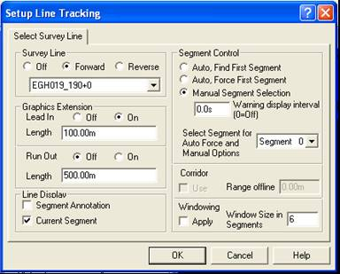
Figure 73. WinFrog’s “Setup Line Tracking” window with setup for heat flow surveys.

Figure 74. WinFrog’s “Raw Logging Warning” window.

The line tracking will appear on one end of the chirp line. The vessel will approach the chirp line from this dotted end (Fig. 72).

TROUBLESHOOTING: the "Setup Line Tracking" window will not open if:

  - The FX (Start) button on the speed toolbar is still active. Hit Stop.

  - Click on “Configure” in the main menu bar→ Data Events→ Setup→ An “Event Configuration” window will open. On the Event Start box click on “Off” (at this point, the “Manual Start” button should not be active)→ Hit OK. The “Event Configuration” window can also be opened by right clicking on the Vehicle’s window.
  - WINFROG DATA EVENTS SETUP (FOR AUTOMATIC FIX MARKS IN CHIRP SOFTWARE)

To set up the manual start for the chirp:

- On the top, left of WinFrog, under the main menu bar, the Start (FX) and Stop buttons are usually inactive (Fig. 75).

Figure 75. Inactive “Start” (FX) and “Stop” buttons for the chirp in WinFrog.

- Right click on the Vehicle-1 text window→ Setup Data Events. An “Event Configuration” window will open (Fig. 76). Another way of doing this is by clicking on “Configure” in the main menu bar→ Data Events→ Setup. Confirm that the “Interval” on the “Trigger” box is set on 100 m. On the “Event Start” box, click on the “Manual Start” button→ Hit OK.

A “Distance Fixing” window will appear (Fig. 77)→ Ignore it and hit OK.

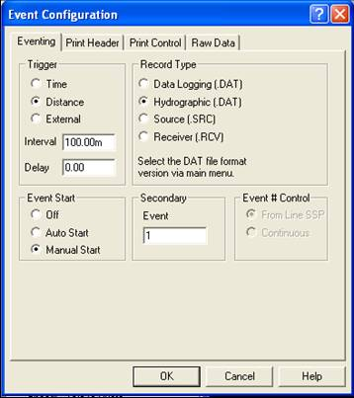
Figure 76. WinFrog’s “Event Configuration” window with proper setup for heat flow chirping.

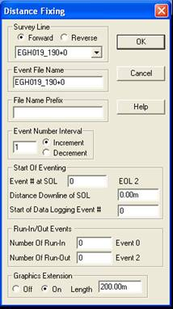
Figure 77. WinFrog’s “Distance Fixing” window.

These Data Events will be later activated on WinFrog. While they are, the program will automatically send a “fix” or event mark to the Chirp system on Discovery for every 100 m traveled down the selected survey line. These three fixes are composed of vertical, dashed lines that appear on the recorded chirp image of the sub-seabed. The first mark depicts the start of the line (0 m down line), the second one indicates the middle of the core location (100 m down line) or bulls-eye and the third fix shows the end of the survey line (200 m down line).

- Three consecutive warning windows will appear (Fig. 78)→ Click Yes on all.

Figure 78. WinFrog warning windows

SECTION 6:
GENERAL PROCEDURES FOR HEAL FLOW AND GEOCHEMICAL CORING

- PROCEDURES TO FOLLOW SHORTLY BEFORE REACHING A CHIRP SURVEY LINE

About 500 m before reaching the dashed end of the survey line, preparing for recording must commence.

  - IN THE WINFROG PROGRAM

- Right click on the Vehicle-1 text window→ Configure Offsets→ A “Configure Offsets” window will appear. Click on the “Chirp” button→ OK. The setting on the Vehicle-1 text window will change from “A-Frame” to “Chirp” (Fig. 79). This will move the DGPS transponder fix to the chirp of the vessel (Fig. 80).

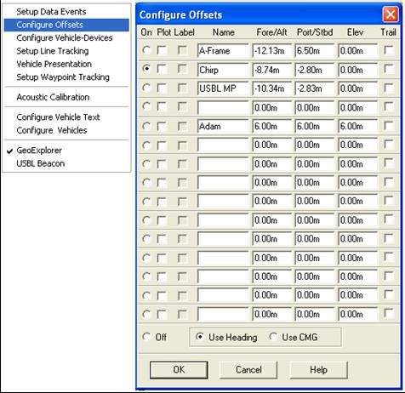
Figure 79. WinFrog’s “Configure Offsets” window set on the “Chirp”.

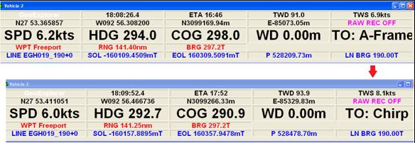
Figure 80. Vehicle settings changed from the vessel’s “A-frame” to the “Chirp”.

- Right click on the text windows for both Vehicles-2 and 3. From the bottom of the pop up window select the respective vessel (Ex. GeoExplorer) (Fig. 81).

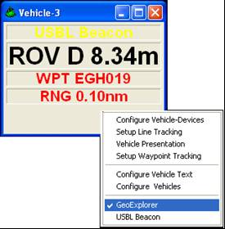
Figure 81. Configuring WinFrog’s vehicles on the vessel.

- Right Click on the Graphics-2 screen (one visible to crew)→ Configure→ Open the “Center” tab→ Select the “Center on Vehicle” button (Fig. 82). This keeps the vessel centered on the screen as it approaches the track-line. Clicking on this screen again will undo this setting.
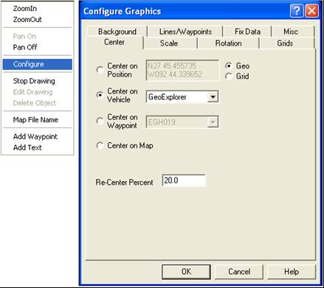
Figure 82. Centering the Graphics-2 screen on the vehicle in WinFrog.

  - IN THE EDGE TECH DISCOVER PROGRAM

- Click on the “Ping SB+-” button on the speed toolbar. This will initiate the chirping. Real-time data from the sub-sea bed will be displayed as an image on the Main Data window (Fig. 83).

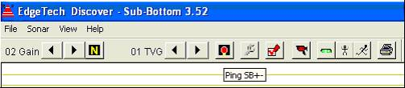
Figure 83. Initiating the chirp by pressing the “Ping SB+-“ button on the speed toolbar in Discover.

- In the Main Data window zoom in on the image displaying the sub-bottom: a left click and drag of the mouse over the depth scale of interest is used to dynamically adjust the zoom factor (Fig. 84). A maximum zoom out can be also achieved by double clicking on the screen. To un-zoom, left click once.

NOTE: if a strange depth is displayed, the scrawl bar must be dragged all the way down, which should make the correction.

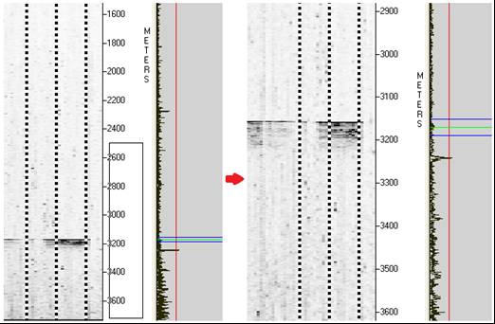
Figure 84. Adjusting the depth scale for the sub-bottom image on Discover.

- On the Wave Form display, properly align the blue, red and green lines with the bottom while recording (Fig. 85):

- The red threshold line can be set to track either strong or weak bottom reflections (peaks). If they surpass the right side of the Threshold line (red), then the bottom tracker line (green) will adjust appropriately and pick the bottom. The program uses these peaks to recognize the seabed. This can also be manually adjusted by left clicking on the site where the red and green line should be located.

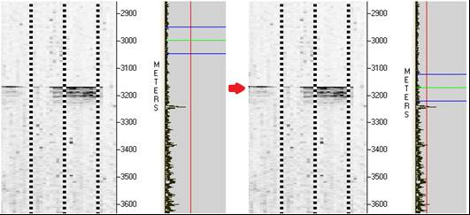
Figure 85. Aligning the red, green and blue lines with the sub-bottom image on Discover.

- Click on the “Control Panel Options” button (“wrench” button) on the speed toolbar (also found under the Sonar menu) (Fig. 86). An “Options” window will open (Fig. 87).

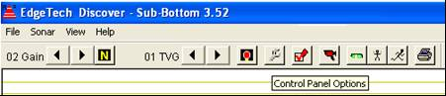
Figure 86. Opening the “Control Panel Options” window via the speed toolbar in Discover.

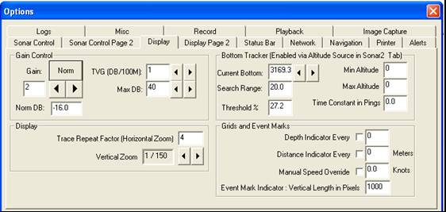Figure 87. Discover’s “Control Panel Options” window with the “Display” tab open.

How far apart the “Search Range” lines (blue) and “Bottom Tracker” line (green) are can be altered by changing the number on the “Search Range” under the “Display” tab of the “Options” window. The “Search Range” should be kept between 25 and 50. Another way to set the tracking window width (the distance between the two blue lines) is by left clicking and dragging the mouse in the area around the pick (Fig. 88).

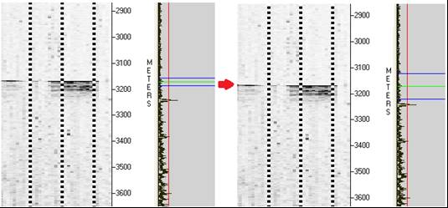
Figure 88. Adjusting the tracking window width in Discover.

- The image displayed of the bottom must be clearly defined and the darkness adjusted appropriately. On the “Options” window→ Click on the “Display” tab→ Increase the number on the “Gain” box (Fig. 87). Note that increasing the gain will cause the data to be amplified more in the display window; decreasing the gain will do the opposite.

This adjustment must be made before recording of the bottom image begins (it does not alter an already recorded picture). This procedure can also be performed by using the buttons on the left of the speed toolbar (Fig. 86).

- Naming the appropriate core: On the “Options” Window→ Click on the “Record” tab→ Type in the “File” box the name of the core with an underscore and the line heading (azimuth). Ex: if the chirp line for EGM019 has a heading of 190°, the name should be EGM019_190 (Fig. 89).

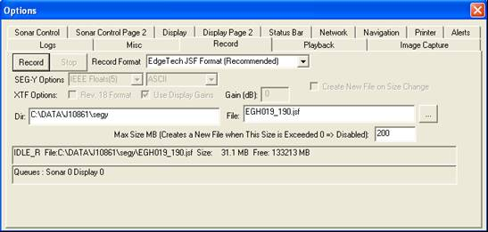
Figure 89. The “Record” tab on the “Options” window in Discover.

- PROCEDURES TO FOLLOW TO RUN THE SURVEY LINE

Chirp profiles of the sub-seabed are run to provide information on the near surface structure and precise water depth.

  - RUNNING THE CHIRP LINE AND RECORDING THE SUB-BOTTOM IMAGE

When vessel reaches the dashed end of the survey line:

- On the DPR, record the time when running the chirp line starts.

- For deep water lines of 2000 m or more the vessel must move at a speed of around 3 knots or slightly slower, to facilitate clear data recording of the sub-bottom. Monitor this and communicate with the vessel’s bridge.

- On WinFrog, click on the green-white “FX” button (Start) on the speed toolbar to activate the “fixes” or event marks to the chirp system (Fig. 90). These three fixes are composed of vertical, dashed lines that appear on the recorded chirp image of the sub-seabed. The first mark depicts the start of the line, the second one indicates the middle of the core location or bulls-eye and the third fix shows the end of the survey line.

NOTE: if this manual set is unsuccessfully programmed, then the navigator must manually click on “New Mark” on the speed toolbar of the Discover program to add fixes (Fig. 91). If the “FX” button on the speed toolbar in WinFrog is gray, it is inactive (Fig. 75).

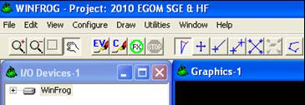
Figure 90. Active “Start” (FX) button for the chirp in WinFrog’s speed toolbar.

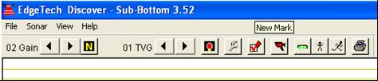
Figure 91. “New Mark” speed toolbar button on Discover.

- When the vessel has run 1/3 of the dashed line, on the Discover program:

- On the “Options” window→ Click on the “Record” Tab→ Hit “Record” (Fig. 89). This can also be achieved by clicking on the “Record” button in the speed toolbar (Fig. 92).

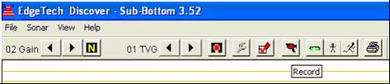
Figure 92. “Record” speed toolbar button on Discover.

- The progress of the recording and the appearing of the three marks must be monitored.

- When the end of the chirp line has been reached and the last fix appears on the image display: 1) Hit “Stop” on the “Record” tab of Discover’s “Options” window (Fig. 89); 2) Hit “Stop” on WinFrog’s speed toolbar (Fig. 93).

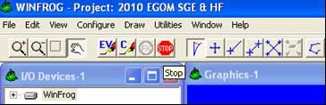
Figure 93. Active “Stop” (FX) button for the chirp in WinFrog’s speed toolbar.

- A “Distance Fixing” window will open→ Press “Cancel” to stop the data events.

- If recorded image of the sub-seabed is acceptable, request the vessel’s bridge to head to target site to begin coring.

- On the DPR, record the time when running the chirp line ended.

  - RE-RUNNING A CHIRP LINE

Different conditions (weather, currents, etc.) can produce blurry sub-bottom images. Communication with the vessel’s bridge about which of the following three is the best course of action is necessary:

- Crabbing the boat: crabbing is to cause to move or scurry sideways or diagonally. Used in vessel maneuvering to compensate for drift (Fig. 94).

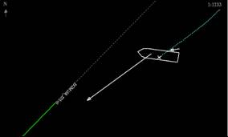
Figure 94. A WinFrog’s graphics screen displaying a vessel crabbing while heading to the survey line.

- Changing the direction in which the chirp line is run (starting chirp line from the other end): On WinFrog, Right click on Vehicle-1 text screen→ A “Setup Line Tracking” window will open. To run the survey line on the opposite direction: under “Survey Line”, click on the “Reverse” button (Fig. 95).

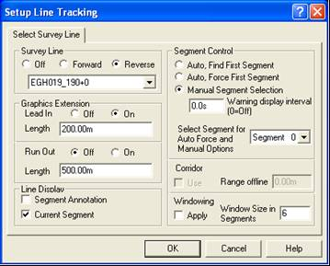
Figure 95. WinFrog’s “Survey Line Tracking” window displaying the “Reverse” option selected.
- Survey line heading change: if an inappropriate azimuth is used, an unclear sub-seabed image can be obtained (Fig. 96), which can be corrected using the proper one (Fig. 97).

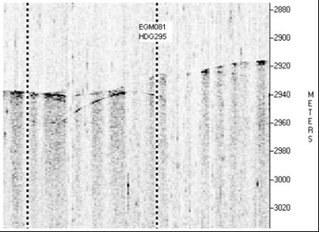
Figure 96. Unclear image recorded of EGM081’s core sub-bottom because of an inappropriate survey line heading (HDG295).

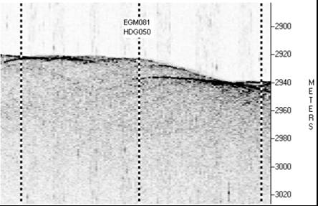
Figure 97. Clear image recorded of EGM081’s core sub-bottom because of an appropriate survey line heading (HDG050).

- On the Discovery’s Main Data window, place mouse cursor on the middle fix, where the bottom surface is located. The depth will be displayed on the bottom left of the screen (Fig. 98).

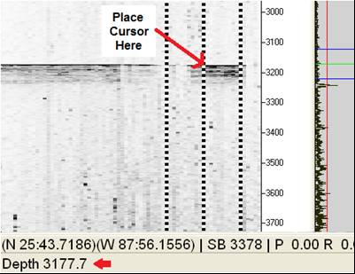
Figure 98. Displaying the sub-bottom’s depth on Discover with the cursor.

- On WinFrog’s computer, under “All Programs”→ Accessories→ Notepad. Writing must be made in a large font. For:

- Geochemical coring: include: 1) The Core’s ID; 2) Depth; 3) Time it hit: 4) Time it must be retrieved (10 minutes after strike). Fill out the information for the events as they take place. Place on top, left corner of the Graphics-2 screen for the vessel’s bridge and winchman (Fig. 99 and 100). This is used when the top-black banner is not available for information display.

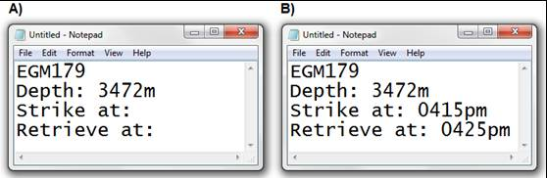
Figure 99. Notepads for geochemical coring with core information for winchman and bridge: A) Preliminary one ready before strike; 2) Filled out one after strike.

- Heat flow survey: include: 1) The core ID; 2) Total depth; 3) Depth the barrel must be paused for 3 minutes (50 m before total depth); 4) The time it struck and the time it must be retrieved. In a Pogo heat flow the barrel is consecutively buried and retrieved twice. Account for this in the notepad (Fig. 101). Fill out the information as the events take place, which is important for the winchman and bridge to keep track of the process (Fig. 102). Place on top, left corner of the Graphics-2 screen for the vessel’s bridge and winchman (Fig. 100). This is used when the top-black banner is not available for information display.

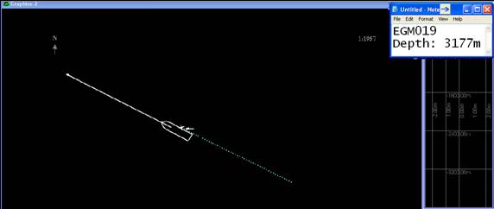
Figure 100. Proper positioning of Notepad with core information for winchman and bridge on WinFrog’s Screen 2.

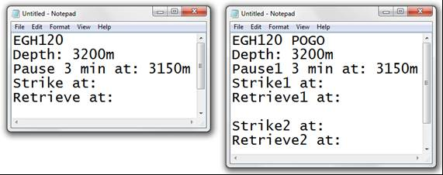
Figure 101. Preliminary notepads with core information for regular and Pogo heat flow surveys (before strike).

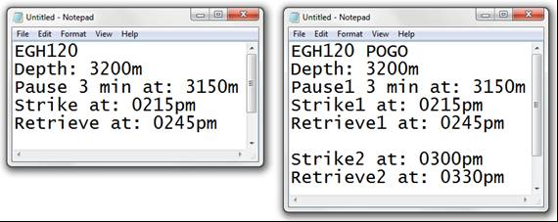
Figure 102. Filled out notepads with core information for regular and Pogo heat flow surveys (after strike).
  - PROCESSING THE SUB-BOTTOM CHIRP IMAGE FROM THE DISCOVER PROGRAM

- Click on the “Playback” tab of the “Options” window. To open the file: press the button with three dots next to the “File” box. Open file and hit “Playback” (Fig. 103).

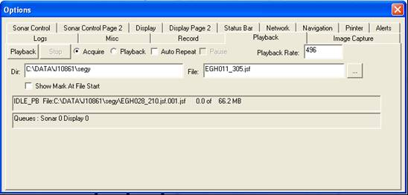
Figure 103. Discover’s “Control Panel Options” window with the “Playback” tab open.

- Adjusting the horizontal zoom: on the “Options” Window→ click on the “Display” Tab→ Change the number on the “Trace Repeat Factor (Horizontal Zoom)” and click on the recorded image (Fig. 103).

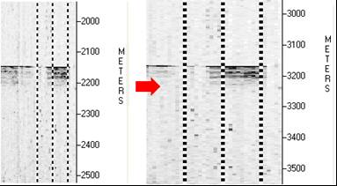
Figure 104. Adjusting the horizontal zoom on the recorded sub-bottom image.

- If necessary, adjust the depth scale as previously described in this Section.

Simultaneously hit the “Alt + Print Screen” buttons on the keyboard. Open the “Paint” program under the computer’s accessories→ Paste. Use the selection tool to draw a section box around the three fixes. The “meters” label on the depth Y-axis must be included and the image selected must be composed by approximately 2/3 area below bottom surface and 1/3 over. Copy→ Open the file named “template.bmp”. This template has the appropriate size needed for the final electronic Corelog report→ Paste and center the image→ Use the text tool to label the middle fix with the core ID (Ex. EGM123) and the line heading (Ex. HDG250) underneath (Fig. 104). Name the file as the Core ID followed by an underscore and the heading. Also, it must be under a “.bmp” format.
WARNING: Take caution as to not save as the “template.bmp”.

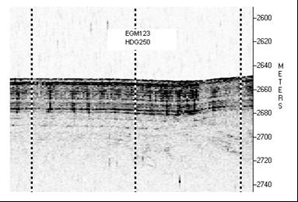
Figure 105. Image of the sub-bottom with proper format for the CoreLog.

- PREPARING FOR CORING BEFORE REACHING THE STATION

- Right Click on the Graphics-2 screen of WinFrog (one visible to crew)→ Configure→ Open the “Center” tab→ Select the “Center on Waypoint” button (Fig. 106). The image should be expanded or contracted as necessary using the speed toolbar icons.

NOTES: 1) This keeps the main target centered on the screen. Clicking on this screen will undo this setting; 2) Be sure to select the correct, active waypoint from the scrawl down menu. It will not be automatically set to the active site.

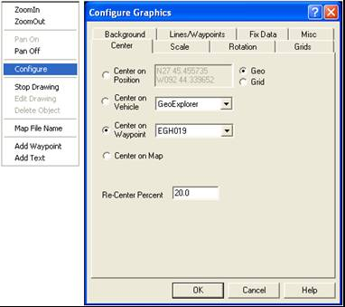
Figure 106. WinFrog’s “Configure Graphics” window with the “Center on Waypoint” selected.
- Right click on WinFrog’s Vehicle-1 text window→ Configure Offsets→ A “Configure Offsets” window will appear (Fig. 107)→ Click on the “A-Frame” button→ OK.

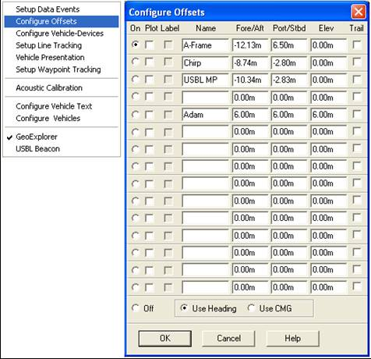
Figure 107. WinFrog’s “Configure Offsets” window set on the “A-frame”.

The setting on the Vehicle-1 text window will change from “Chirp” to “A-Frame” (Fig. 108). This will move the DGPS transponder fix to the A-frame of the vessel. The ass indicator of the boat will then show on the WinFrog Graphics screen (depicted as a small cross).

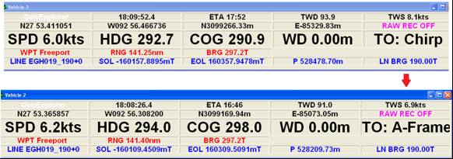
Figure 108. Vehicle settings changed from the vessel’s “Chirp” to the “A-frame”.

- On WinFrog, Right click on the text screen of Vehicle-3 (the beacon’s)→ A window will open, select “USBL Beacon” (Fig. 106).

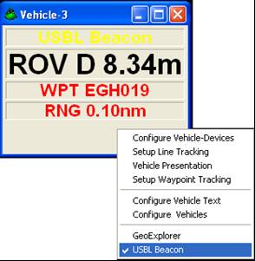
Figure 109. Vehicle settings configured on the vessel’s USBL beacon.

- PROCEDURES TO FOLLOW ON STATION

On the DPR, record the time of deployment of the core rig. If for some reason, the exact time is missed it can be mathematically calculated: the barrel travels at about 22 m/min; so the total distance traveled should be divided by 22 and the result subtracted from the time the barrel struck.

  - TRACKING THE BEACON AFTER CORE RIG DEPLOYMENT

Follow the procedure described on step 2.5 of Section 2 (pg. 30).

  - STRIKE OF BARREL

- When the winchman calls “On Bottom”, click on the Graphics-2 screen (to activate it) and hit the keyboard’s F10 button immediately→ A “Manual Event” window will open→ In the “Comment” box insert the name of the Waypoint followed by the Wire depth in meters, which is provided by the winchman→ OK (Fig. 110).

NOTE: If the wire information is mistakenly not included in the title, it should be manually written on the printout.

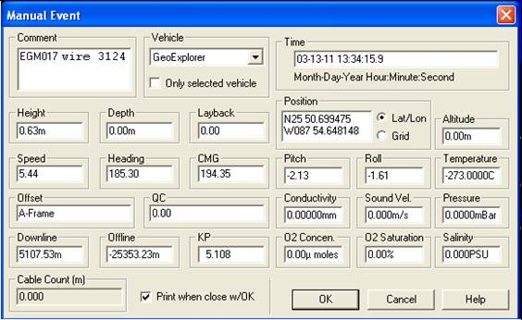
Figure 110. WinFrog´s “Manual Event” window with core strike location information.

TROUBLESHOOTING: If the F10 button is not opening the “Manual Event” window:

- Check the bottom screen of WinFrog to see if there is another window that needs to be closed (the program does not allow more than one popup window to be active at a time).

- Make sure the Graphics-2 screen was the one active (because the “Manual Event” can’t be recorded on it if it’s not so). That is the reason it has to be selected before hitting F10.

- The “Manual Start” for the chirp must be turned off: Right click on the Vehicle-1 text window→ Setup Data Events. An “Event Configuration” window will open. On the Event Start box, click on “Off”→ OK (Fig. 111). Another way of doing this is by opening “Configure” in the main menu bar→ Data Events→ Setup.

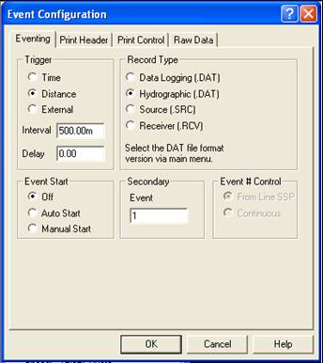
Figure 111. Turning the “Event Start” for the chirping off in WinFrog’s “Event Configuration” window.

- A printout will be produced and a mark will appear on the screen showing the barrel’s burial location (used for tracking purposes). If the behavior of the beacon was erratic, make a note on the printout, underline the coordinates for the “A-frame” and cross out the ones for the beacon. This will inform the laboratory technician which coordinates to use when filling out the core lab report, which should also be used on the electronic CoreLog (as specified previously).

Both the Lab Report and this Manual Event Report will be placed together on a binder, one after the other. An example of a “Manual Event” printout and the lab report for both a core in which the beacon’s signal was normal and erratic are included in Annexes 4 and 5 respectively.

- The barrel will be retrieved shortly after strike: 10 minutes for the geochemical coring, 30 minutes for the heat flow.

NOTE: remember that on a Pogo heat flow survey, the barrel is buried twice in a consecutive manner.

  - BEFORE BARREL IS BACK ON DECK

Activate the next destination (waypoint) and request the vessel’s bridge to wait for confirmation of successful core recovery before heading to site.

  - AFTER FULL BARREL RETRIEVAL

- On the DPR record the time the core rig has been retrieved and is on deck.

- According to the performed coring procedure:

- Geochemical Piston Core: inform vessel’s bridge to head to next site if the sediment was successfully recovered or if a re-shoot is necessary. Fill out the CoreLog Database as described in step 1.3 of Section 2 (pg. 20) and skip step 4.4.2 of Section 6. This finalizes the procedures for this coring event.

- Heat Flow Survey: continue with the next step (4.4.1).

    - VERIFICATION OF SUCCESSFUL HEAT FLOW DATA RECOVERY

Follow the procedures described on TDI’s latest approved heat flow SOP, available in the vessel’s navigation station to retrieve the data. Figure 112 depicts bad results obtained. Note the inacceptable fluctuations after the first peak signaled with a red arrow (a reshoot must be preformed). Figure 113 shows perfect data recorded, with smooth peaks and lines without fluctuations.
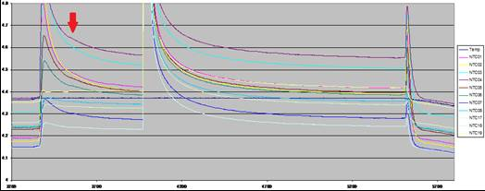
Figure 112. Inacceptable data results obtained from a heat flow survey. Red arrow points to bad fluctuations after first peak.

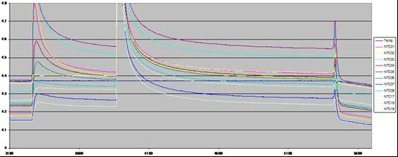
Figure 113. Good data results obtained from a heat flow survey.
Inform vessel’s bridge to head to next site if the data was successfully recovered or if a re-shoot is necessary.

    - FILLING OUT THE CORELOG DATABASE

- Fill out the CoreLog Database as described in step 1.3 of Section 2 (pg. 20). This finalizes the procedures for this coring event.

ANNEX 1

DAILY PROGRESS REPORT

Ending 2400 Friday 12 November 2010

R/V Brooks McCall TDI-Brooks International, Inc
e-mail: bmccstaff@txcyber.com e-mail: drjmbrooks@aol.com
Nav Room Sailor: 011-870-773-150-801 (primary) Phone: 979-696-3634 (Jim Brooks mobile)
Nav Room Iridium: 011-881-641-461-357 Phone: 979-693-3446 (Main office in Texas)
TDI-Brooks Job# J10864 Report number: 07 LLOG

Mississippi Canyon 547 Geotechnical Survey – CPT Stinger Acquisition

Weather summary at 0700 hrs this day:
Wind |  | Sea |  | Sea |  | Air Visibility |  | Sky
NE 8-12 kt |  | Swell |  | 2-4ft |  | Clear |  | P/Cldy

Event Log for today (UTC = Local)
Site | Start | End | Activity | Depth |  | Comments
MC547 | 0000 | 0600 | Standing by |  |  | Off shift
MC547 | 0600 | 0610 | Daily Meeting |  |  | Conducted daily all-hands meeting
CPT7 short | 0615 | 0630 | Rigging |  |  | CPT Stinger, 38ft barrel set, 45ft pendant
CPT7 short | 0630 | 0649 | Deploying CPT |  | 917m | On bottom 5.14m from target, 44ft trigger
CPT7 short | 0649 | 0701 | Logging data |  | 917m | Logged for 10 min
CPT7 short | 0701 | 0736 | Retrieving CPT |  | 917m | Penetration, buried
Transit | 0736 | 0825 | Processing/Rigging |  |  | Full 30ft push, good data, clear water
CPT9 short | 0825 | 0847 | Deploying CPT |  | 934m | On bottom 4.51m from target, 44ft trigger
CPT9 short | 0847 | 0858 | Logging data |  | 934m | Logged for 10 min
CPT9 short | 0858 | 0931 | Retrieving CPT |  | 934m | Penetration, buried
Transit | 0931 | 1029 | Processing/Rigging |  |  | Full 30ft push, good data, clear water
CPT10 short | 1029 | 1045 | Deploying CPT |  | 882m | On bottom 8.57m from target, 44ft trigger
CPT10 short | 1045 | 1058 | Logging data |  | 882m | Logged for 10 min
CPT10 short | 1058 | 1133 | Retrieving CPT | 882m |  | Penetration, buried
Transit | 1133 | 1220 | Processing/Rigging |  |  | Full 30ft push, good data, cloudy water
CPT12 short | 1220 | 1242 | Deploying CPT | 898m |  | On bottom 6.94m from target, 44ft trigger
CPT12 short | 1242 | 1252 | Logging data | 898m |  | Logged for 10 min
CPT12 short | 1252 | 1321 | Retrieving CPT | 898m |  | Penetration, buried
Transit | 1321 | 1425 | Processing/Rigging |  |  | Full 30ft push, good data, clear water
CPT3R short | 1425 | 1447 | Deploying CPT | 965m |  | On bottom 9.88m from target, 44ft trigger
CPT3R short | 1447 | 1457 | Logging data | 965m |  | Logged for 10 min
CPT3R short | 1457 | 1528 | Retrieving CPT | 965m |  | Penetration, buried
CPT3R short | 1528 | 1606 | Processing |  |  | Full 30ft push, good data, clear water
Transit | 1606 | 2400 | Transiting |  |  | Job complete, headed to Fourchon dock

HSE Statistics (as of 2400 hrs this day):
Fatalities: |  |  |  |  |  |  | 0 | Total: | 0
Occupational Illness: |  |  |  |  |  |  | 0 | Total: | 0
Lost Time Injury: |  |  |  |  |  |  | 0 | Total: | 0
First Aid Case: |  |  |  |  |  |  | 0 | Total: | 0
Near Miss: |  |  |  |  |  |  | 0 | Total: | 0
Environ. Incident: |  |  |  |  |  |  | 0 | Total: | 0
Equipment Damage: |  |  |  |  |  |  | 0 | Total: | 0
Safety Drill: |  |  |  |  |  |  | 0 | Total: | 2
JSA review: |  |  |  |  |  |  | 0 | Total: | 2
All-Hands Meeting: |  |  |  |  |  |  | 1 | Total: | 7
Safety Mgmt Meeting: |  |  |  |  |  |  | 0 | Total: | 0
MOC Meeting: |  |  |  |  |  |  | 0 | Total: | 0
Toolbox Meetings |  |  |  |  |  |  | 5 | Total: | 35
Safety observation cards |  |  |  |  |  |  | 3 | Total: | 3

Production (as of 2400 hrs this day):
Jumbo Piston Cores (ea)
Job Plan | Today | Previous | Remaining
0 | 0 | 0 | 0

CPT-Stinger Drops (sets of 2, long & short)
Job Plan | Today | Previous total | Remaining
8 shorts | 5 shorts | 3 shorts | 0 shorts
8 longs | 0 longs | 8 longs | 0 longs

3-in Piston Cores (ea)
Job Plan | Today | Previous | Remaining
0 | 0 | 0 | 0

Box Cores (ea)
Job Plan | Today | Previous | Remaining
0 | 0 | 0 | 0

Weather Standby (as of 2400 hrs this day):
Weather Standby
Job Plan | Today (hrs) | Previous (hrs) | To-Date for Job (hrs)
Decision by mgmt team | 0 | 0 | 0

Man-Hours using 12-hr work shifts (as of 2400 hrs this day):
Affiliation | Personnel | Previous (hrs) | Today (hrs) | To-Date (hrs)
TDI-Brooks Crew | 8 | 672 | 96 | 768
TDI-Brooks Staff | 9 | 756 | 108 | 864
Client Reps | 1 | 84 | 12 | 96
TOTAL ON-BOARD | 18 | 1512 | 216 | 1728

Tanks (as of 2400 hrs this day):
Fuel (gal) | Consumed | Remaining |  | Water (gal) | Consumed | Remaining
32,684 | 440 | 32,244 |  | 39,000 | WM | 39,000

TDI-Brooks Party Chief Comments:
Starting with this report: 1) On the Event Log Table, time spent on bottom logging data was added: 2) On the CTP-Stinger Drops Table, separate rows were created for long and short ones. We acquired the remainder of the CPT site data today, and then headed to the dock at Fourchon. Job complete.

Client Technical Representative Comments:
No additional comment.

Planned Activities next 24 hours (per Party Chief):
At the Fourchon dock by 0930 hrs.

_____________________ _____________________ _____________________
(Add name) (Add name) (Add name)
Party Chief Client Technical Rep Client HSE Rep
TDI-Brooks

ANNEX 2

DAILY PROGRESS REPORT

Ending 2400 Sunday 14 November 2010

R/V Brooks McCall TDI-Brooks International, Inc
e-mail: bmccstaff@txcyber.com e-mail: drjmbrooks@aol.com
Nav Room Sailor: 011-870-773-150-801 (primary) Phone: 979-696-3634 (Jim Brooks mobile)
Nav Room Iridium: 011-881-641-461-357 Phone: 979-693-3446 (Main office in Texas)
TDI-Brooks Job# J10846 Report number: 01 BP

BP Kodiak/Kaskida – CPT Stinger Acquisition

Weather summary at 0700 hrs this day:
Wind |  | Sea |  | Sea |  | Air Visibility |  | Sky
SE 5-10kt |  | Swell |  | 0-2ft |  | Clear |  | P/Cldy

Event Log for today (UTC = Local)
Site | Start | End | Activity |  | Depth |  | Comments
T Bells | 0000 | 0600 | Transiting |  |  |  | Off shift
T Bells | 0600 | 0615 |  | Daily Meeting |  |  | Conducted daily all-hands meeting
T Bells | 0615 | 1220 | CPT stinger |  |  |  | Acquiring data at Tubular Bells
T Bells | 1220 | 1250 | Transiting |  |  |  | Transit to Kodiak site
KCPT1 short | 1250 | 1331 | Rigging |  |  |  | CPT Stinger, 38ft barrel set, 45ft pendant
KCPT1 short | 1331 | 1405 | Deploying CPT |  | 1435m |  | On bottom 5.77m from target, 46ft trigger
KCPT1 short | 1405 | 1416 | Logging data |  | 1435m |  | Logged for 11min
KCPT1 short | 1416 | 1501 | Retrieving CPT |  | 1435m |  | Penetration, buried
Transit | 1501 | 1548 | Processing/Rigging |  |  |  | Full 30ft push, good data, clear water
KCPT10 short | 1548 | 1627 | Deploying CPT |  | 1520m |  | On bottom 1.71m from target, 46ft trigger
KCPT10 short | 1627 | 1638 | Logging data |  | 1520m |  | Logged for 11min
KCPT10 short | 1638 | 1726 | Retrieving CPT |  | 1520m |  | Penetration, buried
KCPT10 short | 1726 | 1735 | Processing |  |  |  | Full 30ft push, good data, clear water
Stand by | 1735 | 1900 | Rigging |  |  |  | Rigging for long (58ft barrel) drops
Stand by | 1900 | 1930 | Standing by |  |  |  | Off shift
Stand by | 1930 | 2000 | Safety Drills |  |  |  | Fire Drill and Abandon Ship Drill
Stand by | 2000 | 2400 | Standing by |  |  |  | Off shift

HSE Statistics (as of 2400 hrs this day):
Fatalities: |  |  |  |  |  |  | 0 | Total: | 0
Occupational Illness: |  |  |  |  |  |  | 0 | Total: | 0
Lost Time Injury: |  |  |  |  |  |  | 0 | Total: | 0
First Aid Case: |  |  |  |  |  |  | 0 | Total: | 0
Near Miss: |  |  |  |  |  |  | 0 | Total: | 0
Environ. Incident: |  |  |  |  |  |  | 0 | Total: | 0
Equipment Damage: |  |  |  |  |  |  | 0 | Total: | 0
Safety Drill: |  |  |  |  |  |  | 2 | Total: | 2
JSA review: |  |  |  |  |  |  | 0 | Total: | 0
All-Hands Meeting: |  |  |  |  |  |  | 1 | Total: | 1
Safety Mgmt Meeting: |  |  |  |  |  |  | 0 | Total: | 0
MOC Meeting: |  |  |  |  |  |  | 0 | Total: | 0
Toolbox Meetings |  |  |  |  |  |  | 5 | Total: | 5
Safety observation cards |  |  |  |  |  |  | 0 | Total: | 0

Production (as of 2400 hrs this day):
Jumbo Piston Cores (ea)
Job Plan | Today | Previous | Remaining
0 | 0 | 0 | 0

CPT-Stinger Drops (sets of 2, long & short)
Job Plan | Today | Previous total | Remaining
2 shorts | 1 short | 0 shorts | 1 short
0 longs | 0 longs | 0 longs | 0 longs

3-in Piston Cores (ea)
Job Plan | Today | Previous | Remaining
0 | 0 | 0 | 0

Box Cores (ea)
Job Plan | Today | Previous | Remaining
0 | 0 | 0 | 0

Weather Standby (as of 2400 hrs this day):
Weather Standby
Job Plan | Today (hrs) | Previous (hrs) | To-Date for Job (hrs)
Decision by mgmt team | 0 | 0 | 0

Man-Hours using 12-hr work shifts (as of 2400 hrs this day):
Affiliation | Personnel | Previous (hrs) | Today (hrs) | To-Date (hrs)
TDI-Brooks Crew | 8 | 0 | 48 | 48
TDI-Brooks Staff | 8 | 0 | 48 | 48
Client Reps | 2 | 0 | 12 | 12
Medic | 1 | 0 | 6 | 6
TOTAL ON-BOARD | 19 | 0 | 114 | 114

Tanks (as of 2400 hrs this day):
Fuel (gal) | Consumed | Remaining |  | Water (gal) | Consumed | Remaining
31,754 | 1,030 | 30,724 |  | 39,000 | WM | 39,000

TDI-Brooks Party Chief Comments:
After acquiring CPT data at Tubular Bells, we transited to Kodiak and acquired good CPT data on two short CPT drops. We have to split the work hours for today between the two jobs.

Client Technical Representative Comments:
No additional comment.

Planned Activities next 24 hours (per Party Chief):
We plan to acquire the remaining CPT site data at Kodiak and then return to Tubular Bells and acquire the long drops.

_____________________ _____________________ _____________________
(Add name) (Add name) (Add name)
Party Chief Client Technical Rep Client HSE Rep
TDI-Brooks

ANNEX 3

DAILY PROGRESS REPORT

Ending 2400 Monday 15 November 2010

R/V Brooks McCall TDI-Brooks International, Inc
e-mail: bmccstaff@txcyber.com e-mail: drjmbrooks@aol.com
Nav Room Sailor: 011-870-773-150-801 (primary) Phone: 979-696-3634 (Jim Brooks mobile)
Nav Room Iridium: 011-881-641-461-357 Phone: 979-693-3446 (Main office in Texas)
TDI-Brooks Job# J10846 Report number: 02 BP

BP Kodiak/Kaskida – CPT Stinger Acquisition

Weather summary at 0700 hrs this day:
Wind |  | Sea |  | Sea |  | Air Visibility |  | Sky
S 18-25kt |  | Heavy |  | 5-8ft |  | Clear |  | P/Cldy

Event Log for today (UTC = Local)
Site | Start | End | Activity |  | Depth |  | Comments
TBells/Kodiak | 0000 | 0600 |  | Standing by |  |  | Off shift. Declared Weather Down at 0600
TBells/Kodiak | 0600 | 0630 |  | Daily Meeting |  |  | Conducted daily all-hands meeting
TBells/Kodiak | 0630 | 0800 |  | Weather Down |  |  | Weather stand by
TBells/Kodiak | 0800 | 0815 |  | Pitch/Roll check |  |  | Monitored pitch and roll and deck awash
TBells/Kodiak | 0800 | 1800 |  | Weather Down |  |  | Weather stand by, monitoring wind/waves
TBells/Kodiak | 1800 | 2400 |  | Standing by |  |  | Off shift. Weather Down

HSE Statistics (as of 2400 hrs this day):
Fatalities: |  |  |  |  |  |  | 0 | Total: | 0
Occupational Illness: |  |  |  |  |  |  | 0 | Total: | 0
Lost Time Injury: |  |  |  |  |  |  | 0 | Total: | 0
First Aid Case: |  |  |  |  |  |  | 0 | Total: | 0
Near Miss: |  |  |  |  |  |  | 0 | Total: | 0
Environ. Incident: |  |  |  |  |  |  | 0 | Total: | 0
Equipment Damage: |  |  |  |  |  |  | 0 | Total: | 0
Safety Drill: |  |  |  |  |  |  | 0 | Total: | 2
JSA review: |  |  |  |  |  |  | 0 | Total: | 0
All-Hands Meeting: |  |  |  |  |  |  | 1 | Total: | 2
Safety Mgmt Meeting: |  |  |  |  |  |  | 0 | Total: | 1
MOC Meeting: |  |  |  |  |  |  | 0 | Total: | 0
Toolbox Meetings |  |  |  |  |  |  | 5 | Total: | 10
Safety observation cards |  |  |  |  |  |  | 1 | Total: | 1

Production (as of 2400 hrs this day):
Jumbo Piston Cores (ea)
Job Plan | Today | Previous | Remaining
0 | 0 | 0 | 0

CPT-Stinger Drops (sets of 2, long & short)
Job Plan | Today | Previous total | Remaining
4 shorts | 0 short | 2 shorts | 2 short
4 longs | 0 longs | 0 longs | 4 longs

3-in Piston Cores (ea)
Job Plan | Today | Previous | Remaining
0 | 0 | 0 | 0

Box Cores (ea)
Job Plan | Today | Previous | Remaining
0 | 0 | 0 | 0

Weather Standby (as of 2400 hrs this day):
Weather Standby
Job Plan | Today (hrs) | Previous (hrs) | To-Date for Job (hrs)
Decision by mgmt team | 24 | 0 | 24

Man-Hours using 12-hr work shifts (as of 2400 hrs this day):
Affiliation | Personnel | Previous (hrs) | Today (hrs) | To-Date (hrs)
TDI-Brooks Crew | 8 | 48 | 48 | 96
TDI-Brooks Staff | 8 | 48 | 48 | 96
Client Reps | 2 | 12 | 12 | 24
Medic | 1 | 6 | 6 | 12
TOTAL ON-BOARD | 19 | 114 | 114 | 228

Tanks (as of 2400 hrs this day):
Fuel (gal) | Consumed | Remaining |  | Water (gal) | Consumed | Remaining
30,724 | 480 | 30,244 |  | 39,000 | WM | 39,000

TDI-Brooks Party Chief Comments:
We monitored pitch and roll and deck awash about 0600 and made a unanimous mgmt team decision to declare Weather Down. We continued to check the wave height, wind speed and direction, and deck awash thru the day, and determined we could not work even late in the day.

Client Technical Representative Comments:
Client and HSE rep initially made call to halt operations due to adverse weather conditions that could possibly affect safety of deck crew working on back deck and performing operations to satisfaction. This decision was agreed to by TDI management.

Planned Activities next 24 hours (per Party Chief):
We may well still be in Weather Down tomorrow. Otherwise we plan to continue CPT data acquisition at Kodiak.

_____________________ _____________________ _____________________
(Add name) (Add name) (Add name)
Party Chief Client Technical Rep Client HSE Rep
TDI-Brooks
ANNEX 4
WinFrog’s Manual Event printout and lab report for core EGM053
(beacon with normal signal)

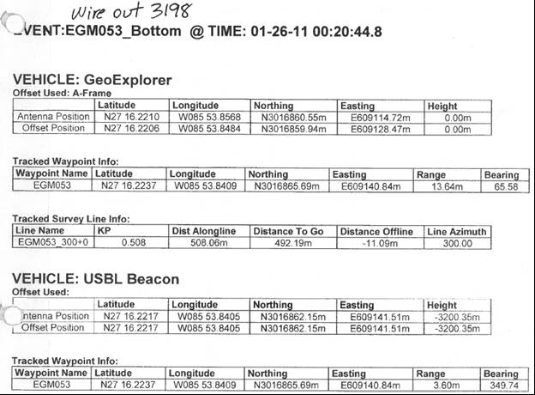

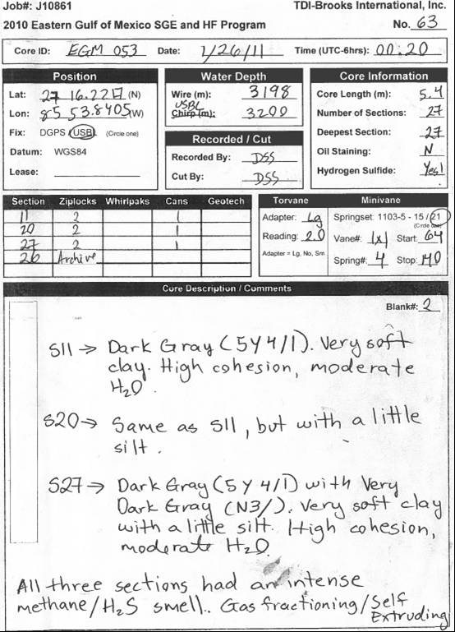
ANNEX 5
WinFrog’s Manual Event printout and lab report for core EGM195
(beacon with erratic signal)

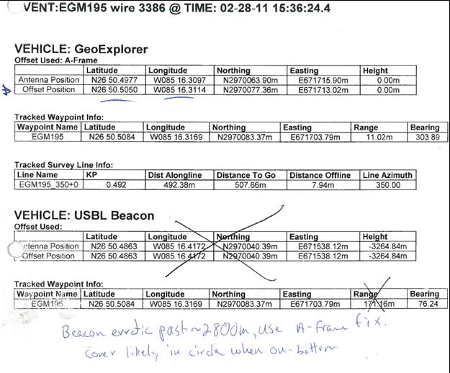

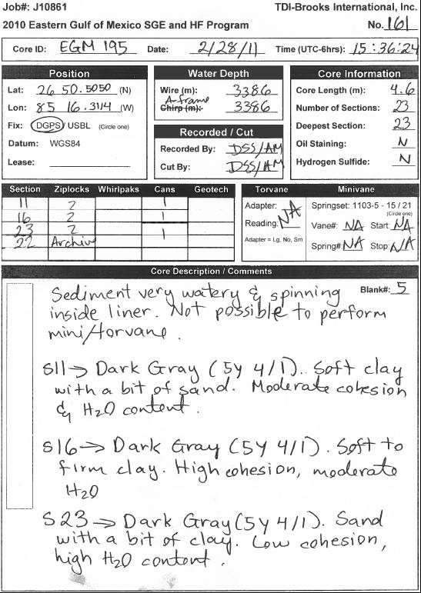

references

Bernard, B.B. November, 2010. Personal communication. Brooks McCall vessel. TDI-Brooks International, Inc.

Bernard, B.B. Brooks, J.M. Baillie, P. Decker, J. Teas, P.A. and Orange, D.L. 2008. Surface Geochemical Exploration and Heat Flow Surveys in Fifteen (15) Frontier Indonesian Basins. 2008. Proceedings, Indonesia Petroleum Association. Thirty-Second Annual Convention and Exhibition. 1-17pp.

EdgeTech. 2007. Discover Sub-Bottom Software User’s Manual. Revision 1.0/May 2007. http://www.EdgeTech.com

Fugro Pelagos, Inc. 1993. WinFrog 3.7 Integrated Navigation System, User’s Guide.

Kongsberg Simrad AS, 1998. apos 4.41 Course Training Guide, Operator Course Manual. Kongsberg Simrad APOS-SSBL & LBL Operation. http://www.kongsberg-simrad.com

Kullman, M. February to March, 2011. Personal communication. GeoExplorer vessel. TDI-Brooks International, Inc.

TDI-Brooks International website: http://www.tdi-bi.com

