Management of Change Process

*Marine Operations*

|  |  |
| --- | --- |
| **TITLE: Short one line description of proposed change** | |
| Shift from 24 hour to 12 hour ops | |
| **Name of Vessel/ Facility** | **Incident date (01-January-2020) and time** |
| Proteus | 9 April 2019 |
| **Client name/ Job location** | **Name of person conducting meeting- PRINT** |
|  | James Howell |
| **Enter into Helm as a meeting—Management of Change** | **Helm meeting #:** |

**Step 1: Proposal Meeting**

This meeting should be conducted by a team including management, workers, contractors and client reps who would be directly affected by the proposed change.

|  |  |  |  |
| --- | --- | --- | --- |
| **Evaluation Team Signatures** | | | |
| **Printed names** | | **Positions** | **Signatures** |
| 1 | **James Howell** | **Party Chief** |  |
| 2 | **David King** | **Client Rep** |  |
| 3 | **Ken Craigue** | **Survey** |  |
| 4 | **Inge Smith** | **Client Rep** |  |
| 5 | **Les Bender** | **Lab Chief** |  |
| 6 | **Frank Rivera** | **Deck Chief** |  |
| 7 |  |  |  |
| 8 |  |  |  |
| 9 |  |  |  |
| 10 |  |  |  |

**Step 2: Risk Analysis**

The team completes this form during the Proposal Meeting

|  |
| --- |
| **1. Briefly describe the current situation/ procedure.** |
| Currently running 24 hour operations |
| **2. Briefly describe the proposed change.** |
| Party Chief proposes switching to 12 hr operations for the next 2-3 days due to insufficient deck crew. Several technical crew sick with cold and fever and Deck Chief medevaced for extreme dehydration resulting from this illness. |
| **3. What is the goal/ purpose of making this change?** |
| Switching to 12 hr ops will allow sick technical crew time to recover. |
| **4. List the positions and departments that will be affected. Ensure each**  **department has a representative participating in this meeting.** |
| Navigation, Lab and Deck Teams |
| **5. What are some potential hazards associated with the proposed change?** |
| None. Change is to mitigate hazards of insufficient crew for 24 hr ops. |
| **6. How will the hazards be mitigated?** |
| No additional hazard |

**Risk Rating**

|  |  |  |  |  |
| --- | --- | --- | --- | --- |
| **Likelihood** | Likely | Medium Risk | High Risk | Extreme Risk |
| Unlikely | Low Risk | Medium Risk | High Risk |
| Highly Unlikely | Insignificant Risk | Low Risk | Medium Risk |
|  | Slightly Harmful | Harmful | Extremely Harmful |
| **Potential Consequences** | | | |

Use the chart above to answer the following questions.

|  |
| --- |
| **7. What is the current likelihood of injury or harm to personnel, equipment or**  **the environment?** |
| ______ Likely _____ Unlikely ___X___Highly Unlikely |
| **8. What is the current potential severity of any harm to personnel, equipment or**  **the environment?** |
| ___X___ Slightly Harmful ______ Harmful ______ Extremely Harmful |
| **9. Using the Risk Rating chart above, what is the current Risk Rating?.** |
| Insignificant |
| **10. What is the likelihood of injury or harm to personnel, equipment or the**  **environment if the change is made?** |
| ______ Likely _____ Unlikely ___X___Highly Unlikely |
| **11. What is the potential severity of any harm to personnel, equipment or the**  **environment if the change is made?** |
| __X____ Slightly Harmful ______ Harmful ______ Extremely Harmful |
| **12. Using the Risk Rating chart above, what would be the new Risk Rating if the**  **change**  **was made?** |
| Insignificant |

**Does the team agree that the change should be implemented?**

**YES or NO**

**If YES, go to the next step - Implementation.**

**If NO, scan and send this signed form with decision to** [**dpa@tdi-bi.com**](mailto:dpa@tdi-bi.com)

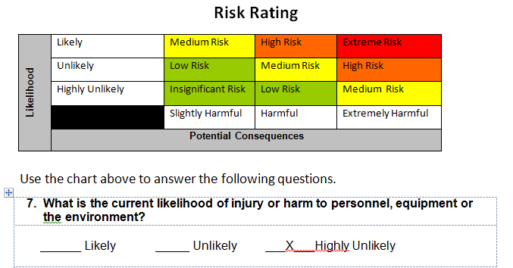

**Step 3: Implementation**

|  |
| --- |
| **13. Type of change:** |
| ______ Emergency ___X__ Urgent ______Minor |
| **14. Nature of the change:** |
| __X____ Operations ______ Equipment ______ Regulatory/ Permits  ______ Personnel ______ Contract Requirements ______ Procedures  ______ Other- Describe: |
| **15. How will the change be communicated to all affected parties? ______ N/A** |
| ______ Toolbox Meeting ______ Training ___X___ HSE or other meeting  ______ Other- describe: |
| **16. How will next shift of workers be advised of the change? ___X___ N/A** |
| ______ Toolbox Meeting ______ Training ______ HSE or other meeting  ______ Other- describe: |
| **17. Who will complete Step 4 and evaluate the effectiveness of the change?** |
| Print name and position: James Howell, Party Chief |
| **18. When will the evaluation be completed? (date/ end of job)** |
| Approximately April 12, 2019 |
| **19. Check if any of the following was needed.** |
| _____ New Training _____ Documentation/ SOPs/ Forms  ______ Regulatory or Permit adjustments ___X___ None or N/A |
| **20. What date was change implemented? (01-January-2020) ____9 April 2019____** |
|  |
| **21. If TEMPORARY, when is it expected to end? _______12 April 2019________** |
|  |

**\*\*When all of Steps 1-3 are completed, email a copy of all pages to** [**dpa@tdi-bi.com**](mailto:dpa@tdi-bi.com)**.**

**Step 4: Close-Out**

|  |  |
| --- | --- |
| *Name of person conducting Close Out- PRINT* | *Close Out evaluation date*  ***(01-January-2020)*** |
| *James Howell* | *15 April 2019* |
| *Did the change accomplish the goal it was supposed to?* | *Date change ended (if temporary)*  ***(01-January-2020)*** |
| *_X_ Yes ___ No* | *15 April 2019* |
| *If no, explain why not. List in detail any lessons learned.* | |
| *Your signature here: _______________________* | |

**\*\*When Step 4 is completed, email a scan of the entire document to dpa@tdi-bi.com.**