Monkey's Fist Knot Tying Instructions
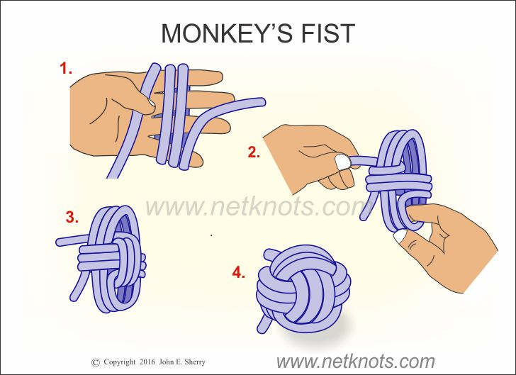
- Take your rope and with the long working end make three wraps around the fingers of your hand.

- While holding the first set of turns in place, make three more turns passing outside the middle of the first three turns. Finish this step by passing the working end around one side of the first set of turns. This sets up the working end for the next step which passes the end through the inside of the previous wraps.

- Now make three turns around the set of wraps made in the previous step, passing through the inside of the knot. Double check that you have made the same number of turns for each step.

- Finishing the knot: At this point a round object can be inserted in the center of the wraps or the standing end of the rope can be tucked inside either with or without a stopper knot at the end as well. Working slowly (and patiently) begin tightening by working on each wrap, starting near the buried stopper knot and finishing with the other end of the rope. Do not pull too hard on the first few wraps. You will need to work your way through the knot more than once. The use of a small screwdriver or awl can help on the last tightening session through the knot.

