WIRE ROPE CLIPS 101

Tuesday, April 18th, 2017
Wire Rope Clips can have lots of helpful uses – they are a simple fitting that can be easily used in the field or shop. Sometimes called a u-bolt or u-bolt clip, they can be used to join two wire rope ends together, make an eye for a pulling application, or when terminating a wire rope on a crane’s hook.
But using clips to create wire rope slings for overhead lifting is NOT one of their many uses. Did you know that not only is it a poor rigging practice to fabricate slings in this manner, in the U.S. it is against the law?
- ASME B30.9 states that wire rope clips shall not be used to fabricate wire rope slings, except where the application of slings prevents the use of prefabricated slings.
- ASME B30.9 also calls for any wire rope clip application to be designed by a qualified person.
- ASME B30.9 states wire rope clips shall be drop-forged steel of single saddle (u-bolt) or double saddle clip. Malleable cast iron clips shall not be used.
- ASME B30.26 contains specific instructions for the use of wire rope clips.
- OSHA 1926.251(c)(4)(iii) states: Eyes in wire rope bridles, slings or bull wires shall not be formed by wire rope clips or knots.
- If you are working in General Industry applications under OSHA 1910, it restricts the use of wire rope clips to form eyes.
Why these restrictions? Wire rope clips diminish the working load limit of the wire rope to generally about 70-75% of its original strength. There are better and more efficient ways to fabricate slings for overhead lifting.
For situations where use of wire rope clips are approved, it’s important to remember the proper way to install the clips. Incorrect installation can reduce the working load limit by 40% or more. The easiest thing is to remember, “never saddle a dead horse.”
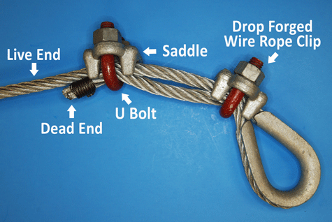
The saddle of the clip is the piece that the U bolt fits into. The dead end of a wire rope is the end of the eye that contains the cut side. The U bolt should always be in contact with the dead end, while the saddle should be on the live end.
In addition, for clips to work properly and gain their design efficiency, the proper number of clips is required and the nuts must be torqued as prescribed by the manufacturer. For more information on proper installation, check out this video from the Crosby Group.
https://www.youtube.com/watch?v=VvvSk-eLhJA
For Crosby’s complete application instructions check out this link: http://www.thecrosbygroup.com/wp-content/uploads/2013/12/56.pdf
If you have more questions on wire rope clips, comment below. Remember that Safety through Education is more than just our motto, it is our guiding principle. If you need training on proper application on any other rigging hardware, reach out to us. We are here for you.

